**Column Chromatography**

Column chromatography is an extremely important technique in organic chemistry. It is a versatile method used to separate and purify organic compounds. And can be used to purify both solids and liquids. Column chromatography is similar in principle to thin layer chromatography; compounds are separated based on their attraction to a solvent (mobile phase) and an adsorbant (stationary phase). Less polar compounds are less attracted to the adsorbant and elute (travel) more quickly than polar compounds. In this experiment, you will assemble a column from a Pasteur pipet and use it to separate the two components of a solid mixture of fluorene and fluorenone.

**Required Reading (Padias):**

|  |  |  |
| --- | --- | --- |
| **Topic** | **2nd Edition** | **3rd Edition** |
| Chromatography, general | pp. 162 – 163 | pp. 164 – 165 |
| Column Chromatography | pp. 164, 172 – 177 | pp. 166, 174 – 179 |

**Special Safety Notes:**

Alumina can be harmful to the lungs. Be careful to avoid inhalation

**Procedure:**

Place 25 mg of the fluorene/fluorenone mixture in a conical vial. Add a spin vane and 0.3 mL of 5% dichloromethane in hexane. Stir to dissolve the solids. While the mixture is stirring, obtain 9 mL of hexane, 2 mL of 30% acetone in hexane and 2 mL of acetone in three separate 25 mL Erlenmeyer flasks. Place three test tubes in a rack, label them “Waste”, “1 (colorless)”, and “2 (yellow)” and begin preparing the column.

Preparing the column:

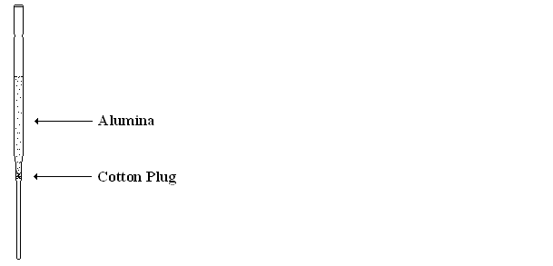Place a very small plug of cotton into a 5.75" Pasteur pipet. Gently lodge the cotton plug into the narrowing region of the pipet using a length of wire. The cotton should be pressed enough to secure it without excessive compression. Add 1.25 g of alumina to the pipet and gently tap it on the bench to compact the solid. Clamp the pipet to a ringstand just above the Waste tube. Using a pipet, add hexane, in portions, to the top of the column (about 3 mL). Allow the hexane to flow through the column. You will see the alumina begin to look "wet". Make certain that there is solvent above the alumina at all times. Continue to add hexane and allow it to flow through the column until the alumina looks homogeneous and free of dry patches or cracks.

Separating the Mixture:

When the solvent reaches the top of the alumina, add the fluorene/fluorenone solution using a pipet. When the solution reaches the top of the alumina, add another 1 mL of hexane dropwise. Begin draining (eluting) the column into Tube #1 (colorless), adding hexane until the yellow band nears the bottom of the column (about 5 mL). Use the acetone to wash any solid fluorene which collects on the pipet tip into Tube #1 (colorless). When the hexane reaches the top of the column, switch the solvent to 30% acetone in hexane. Just before the yellow band reaches the bottom of the column, begin draining the eluent into   
Tube #2 (yellow), adding 30% acetone in hexane until the yellow band elutes completely from the column. Collect any residual eluent in the Waste tube.

TLC Analysis:

Obtain a 5 x 5 cm TLC plate and, using a pencil, label it as shown. Using a 1 L micropipette, spot Tube #1 (colorless) and Tube #2 (yellow) at the origin on lanes labeled #1 and #2 of the TLC plate. Spot standard solutions of fluorene and fluorenone on lanes labeled “ENE” and “ONE” of the TLC plate. Develop the plate in a covered beaker using hexanes:dichloromethane (1:1) as the eluting solvent, removing the plate when the solvent reaches the top line. Allow the eluent to evaporate from the plate and examine it under UV light (254 nm). GENTLY circle each spot with a pencil. Draw the TLC plate to scale in your notebook, showing all spots.



**References**

Pavia, D. L.; Lampman, G. M.; Kriz, G. S.; Engel, R. G. *Introduction to Organic Laboratory Techniques, A Microscale Approach;* 3rd ed.; Brooks/Cole: Pacific Grove, CA, 1999; pp. 115 – 119.

Identification of Components

1. Draw a picture of your TLC plate. Include the Rf values for each spot and the identity of each spot. Show your calculations for the Rf values.

2. What can you conclude about the composition of each fraction (i.e. what is contained in test tubes 1 and 2)? Explain your reasoning.

3. Comment on the efficiency of separation of the two components in your experiment.

**Questions**

**(Fully explain how you arrived at each answer, including all calculations.)**

1. If a column fraction contained two compounds (two spots upon TLC analysis), what could be done to separate the two compounds from one another?

2. In this lab, why was the solvent changed in the middle of the column chromatography procedure?

3. 2-Naphthol can be treated with potassium hydroxide and the resulting product reacted with iodoethane to give a compound (Compound X) which is used as an orange blossom scent in perfumery.

a) Give the structure of Compound X

b) If the reaction did not go to completion and you had to separate Compound X from the starting 2-naphthol by column chromatography using a relatively non-polar solvent, which compound would elute from the column first? Why?