The History of Life

Geol 360, Section 001, Fall Semester 2022

Professor: Gwen M. Daley  Office: Sims 214  Office Hours: R 11:00-1:00 and by appointment  Phone: 323-4973 | Meets: TR 9:30-10:45 (CRN - 16431)  Room: Sims 202  Credit Hours: 3  E-mail: daleyg@winthrop.edu

Prerequisite: One geology or biology course or permission of instructor.

Objectives: To survey the first 4 billion years of life on earth and understand how major geological, biological, and extraterrestrial processes affected the biosphere through time.

Date (TR) | Subject
8/23 | Introduction
8/25 | Sedimentary rocks and the fossil record
8/30 | Taphonomy
9/1 | Introduction to Evolution
9/6 | Origin(s) of Life
9/8 | Complex Life
9/13 | Exam One
9/15 | Archaean and Proterozoic Life; First homework assignment due (9:30 AM)
9/20 | Phylogenetics and Cladistics
9/22 | The Cambrian
9/27 | The Early Paleozoic
9/29 | Exam Two
10/4 | Life on Land; Second homework assignment due (9:30 AM)
10/6 | The Late Paleozoic
10/11 | Diversity Through Time
10/13 | Biostratigraphy (online exercise)
10/18 | The Permian-Triassic Extinction
10/20 | Evolution of the Diapsids I
10/25 | Evolution of the Diapsids II
10/27 | Bony fish, birds, flowers, vermin
11/1 | Exam Three
11/3 | Triassic Life; Third homework assignment due (9:30 AM)
11/8 | Election Day – go vote!
11/10 | Jurassic Life
11/15 | Cretaceous Life
11/17 | The Cretaceous-Paleogene Extinction
11/22 | Paleogene Life
11/24 | Thanksgiving Break
11/29 | Neogene Life
12/1 | The Anthropocene
12/9 | Final Exam (Friday, 11:30)

Schedule subject to change.
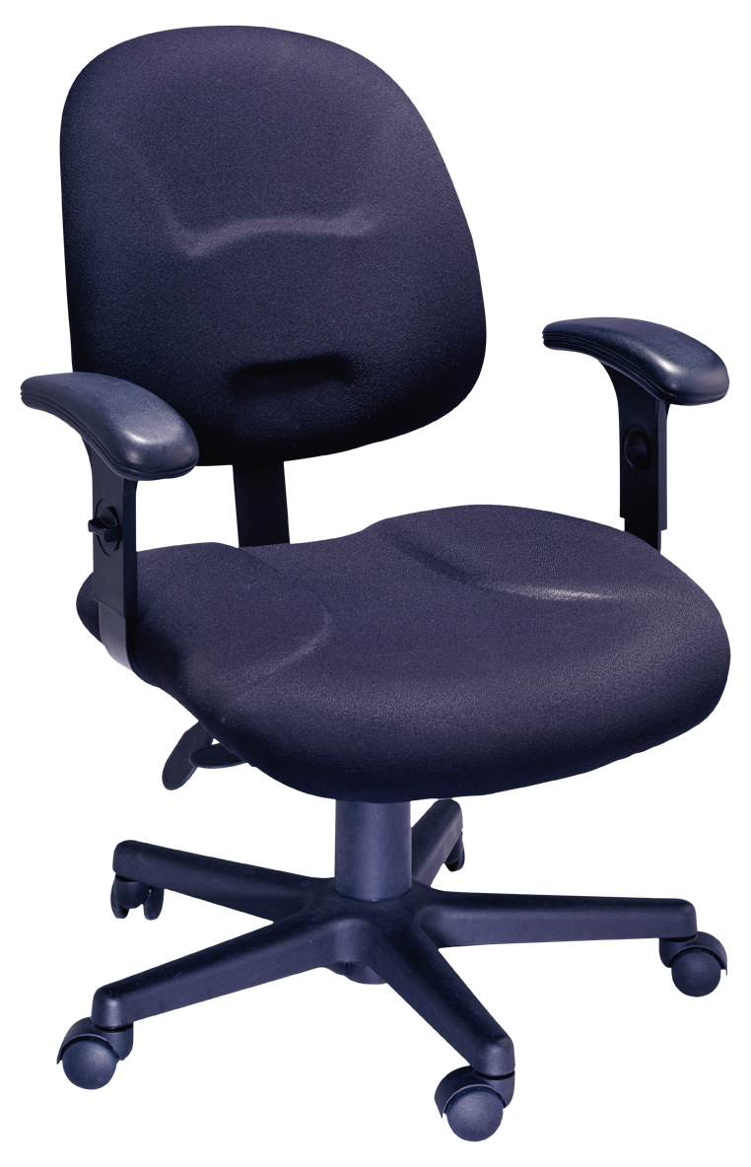 | Office Hours: Please drop by any time during my scheduled office hours if you would like to discuss anything about the class. Because of privacy issues, I will only discuss your grade (including possible grading errors on quizzes, etc.) with you in my office, so If you cannot come to my scheduled office hours, please send me an e-mail to make an appointment. Tuesday and Thursday mornings (after 11:00) and Friday mornings are the best times to make an appointment with me.

Attendance: Class attendance is both mandatory and necessary. Please be in your seat and ready to begin class when class is scheduled to begin. If you arrive at or after 9:30 for a course scheduled to begin at 9:30, you are late for that class meeting, and may not be allowed to participate in that class meeting.

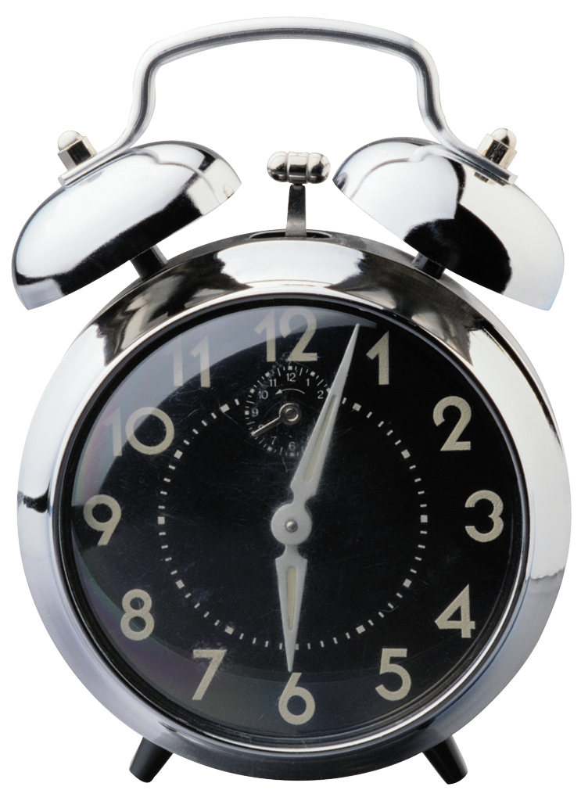 | Attendance in Geol 360 means that you are present and participating in our classroom activities. The professor reserves the right to close the doors to the classroom at any time after the scheduled start time and to not allow late students to enter the classroom after the scheduled start time. Students who fail to come to class on time or are asked to leave will not be allowed to make up missed activities.
If you will not be able to attend a class meeting for any reason, please send an e-mail before the class meeting containing your complete first and last name, the name of the class (Geol 360) and the reason you will be missing the class. As long as the e-mail is sent before the class meeting, you will be allowed to make up missed work. If no e-mail is sent before the class meeting, missed work can only be made up with a Student Absence Notice from the Dean of Students office. Please keep in mind that it is Winthrop University policy (which will be enforced in this course) that any student who miss 25% of class meetings will receive a failing grade for that course (https://www.winthrop.edu/uploadedFiles/recandreg/Catalogs/15-16/Academic-Regulations.pdf).

Student Learning Activities Performance Measures: Grades in this course will be assigned based on:

Exams (3) | 15% each | 45%
Final Exam | 25% | 25%
In class activities | 15% | 15%
Homework Assignments (3) | 5% each | 15%
Total |  | 100%

Exams: There will be three examinations given during the semester as well as a comprehensive final exam.

Homework Assignments: You will be required to turn in 3 homework assignments electronically to Blackboard, each worth 5% of your final grade in Geol 360. For each assignment, you will do some scholarly research about one of the journal articles on the Geol 360 reading list (the asterisked (*) articles at the end of each meeting’s Blackboard page). The goal of the assignments is to analyze how information from other journal articles is used in your article, and how information your article has in turn been used by other researchers. Please submit the homework assignments on time, as no late work will be accepted. Homework can be submitted any time prior to the due date, and I encourage you to turn them in early if you finish them early.

Grades will be calculated on a straight scale:

A | 90.00 - 100.00 | C | 70.00 - 76.99
B+ | 87.00 - 89.99 | D | 60.00 - 69.99
B | 80.00 - 86.99 | F | < 60.00
C+ | 77.00 - 79.99

This grading scale may be adjusted downward as determined by the instructor, but the points needed for each grade will never be higher than indicated above (e.g., a student with more than 90 points will always receive a grade of A). We will use “plus” grades but not “minus” grades because the Winthrop +/- system is not balanced.

Course Evaluations: At the end of the semester, you will be asked to fill out an evaluation of this course through the Qualtrics Survey utility. Instructions for completing this survey will be posted on BlackBoard. The survey will become available late in the semester. I will send messages when the survey becomes active.

Blackboard: The online component for this class is on the Blackboard service. I will post your grades to their secure service as soon as I have them. All of the Powerpoint files we use in class as well as the videos from the internet will also be on the course’s Blackboard site. I will use Blackboard’s e-mail function to contact the class, so please check the e-mail that is listed on Blackboard regularly. If there are any other features that you would like me to activate on Blackboard (e.g., the message board), please let me know.

Student Code of Conduct: Your grade will be based on work you have done. Any attempt to submit anyone else’s work as your own is plagiarism, and thus cheating. You may not consult or work with other students on graded work for this class unless the professor specifically indicates otherwise. Substantially similar work submitted by more than one student will all be assigned a grade of zero, and further action may be taken. Attempting to use any unauthorized material during quizzes or exams (including calculators or other electronic devices) is strictly forbidden, and is cheating.

Assume that ALL time set aside for pop quizzes and exams are examination times, and no other activities may be performed during that time. If you finish a pop quiz before your classmates, please sit quietly and wait for the next activity. If you take out any notes, electronic devices, books or other materials during examination time, your pop quiz or exam will be collected and you will be assigned a grade of zero for that pop quiz or exam. You will also be assigned a grade of zero if you attempt to communicate with another student during that time. Communication includes, but is not limited to, passing notes, speaking or using sign language.

Unethical behavior such as cheating will result in a grade of "F" for the course. All incidents of unethical behavior will be referred to the Dean of Students office, which may decide that further action is justified. Please see your student handbook for more details.

Classroom Decorum: As a courtesy to other students, please be aware of how your behavior (e.g., holding conversations during lecture) affects the learning environment. If your behavior is disruptive, the professor may ask you to leave.

No food of any kind is allowed in Sims 202 at any time. If you choose to bring food into Sims 202, you will be asked to leave and may not be allowed to return for that class meeting. This applies at all times to these rooms, including before the beginning of your scheduled class meeting.

Please turn off all cell phones and other electronic devices. If your cell phone (or other electronic device) makes noise during class time you may be asked to leave. If it makes noise during a quiz, pop quiz or exam, your work will be collected and you will be asked to leave. If a live electronic device is left out (including in the slit desk holes in the tables) during a quiz, pop quiz, or exam, your work will be assigned a grade of zero and you will be asked to leave the class meeting. If the professor observes you playing with an electronic device, even if it is not turned on, you may be asked to leave. If you would like to use a tablet or laptop during class, it must be used to enhance your experience of Geol 360 only. If you choose to do work from another class, cruise social media, or any other activity not related to Geol 360, you will be asked to leave and will not be allowed to use an electronic device in this course again.

If you need to have your cell phone on for a legitimate reason (e.g., waiting for a call about a sick family member or you are on call as an EMT), inform the professor before the beginning of class. It is expected that if the call comes during the class meeting that you will need to leave class to address the issue (obviously, you will be excused from any work).
If you either choose or are asked to leave the classroom during scheduled class meeting time for any reason, please take all of your belongings with you, as you may not be allowed back into the room during that class meeting. If you are not present during class, you will receive a grade of zero for any activity (including, but not limited to, quizzes, exercises, pop quizzes and exams) conducted during that class meeting.

University Level Competencies: Students in Geol 360 will fulfill Winthrop ULC #1: Winthrop graduates think critically and solve problems. Geol 360 students will have ample opportunities to reason logically, evaluate and use evidence, and solve problems related to the study of life on Earth. They will be assessed on their ability to reach well-reasoned conclusions based on scientific evidence.

Class E-mail Notifications: I will send e-mail to registered members of the course from time to time. These e-mails will be addressed to whatever e-mail is listed on BlackBoard, so please check that account regularly.

Students with Disabilities/Need of Accommodations for Access: Winthrop University is committed to providing access to education. If you have a condition that may adversely impact your ability to access academics and/or campus life, and you require specific accommodations to complete this course, contact the Office of Accessibility (OA) at 803-323-3290, or, accessibility@winthrop.edu. Please inform me as early as possible, once you have your official notice of accommodations from the Office of Accessibility.

COVID-19 Syllabi statement - Updated August 11 2022

COVID-19 Statement: The health and safety of the campus community is Winthrop’s top priority. As socially responsible members of this community, everyone is expected to engage in daily health self-monitoring and to stay home (residence hall or off-campus housing) from on-campus class, work, or activities if they begin experiencing any COVID-related symptoms. Please do not attend class if you have a fever or any signs of the COVID virus, do not attend class if your roommate or someone you have close contact with acquires the virus, and be respectful of others’ desire to remain COVID-free. Masking on campus remains optional but strongly encouraged, especially in indoor settings around others. Use the Patient Portal COVID-19 form to report illness or exposure and upload the positive test, if relevant. Students who violate WU guidelines will be asked to comply. Continued failure to comply may result in referral to the Dean of Students Office as a student conduct violation.

COVID-Related Absence: Students should contact Health Services regarding a positive test, close contact, or enhanced COVID-like symptoms. Any student who has either tested positive, has COVID-like symptoms, or has close contact with someone who has COVID, must contact Health Services. Students should log in to the Patient Portal to complete a C19 form and upload the positive test, if relevant. Health Services will communicate with the student on what steps to take next, and if need be, the Dean of Students Office will receive absence verification for required isolation and quarantine. Students who verify their absences through the Dean of Students Office often minimize any academic impact caused by missed class time. Students retain a responsibility to communicate with instructors regarding missed work, and complete assignments in a timely manner as they are able. Regular communication with faculty is expected so that student progress in the course is not negatively impacted. Health Services will only provide dates of absence, not medical information. Please note, residential students who test positive must follow their personal COVID Quarantine and Isolation Plan.

In person classes generally will not have a remote option; students should not expect to have remote access to the class lecture or discussion, even in the case of absence.

We are all in this pandemic together, so please be kind to yourselves and each other. If you need extra time to complete an assignment, ask for an extension. If you get COVID-19, take care of your health and follow Winthrop’s plan.

