GEOL 250 WEATHER ASSIGNMENT SPRING 2015

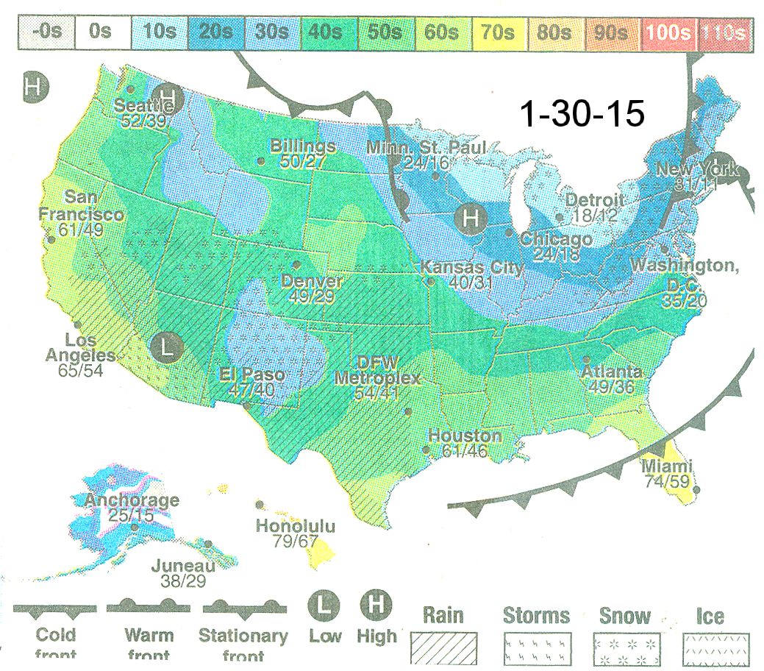

1. For the day indicated on the map above, observe the weather several times during the morning, afternoon, and night and record your observations below. Record below the times of your observations and your estimates of the temperature (cold, cool, warm, hot), cloud cover (clear, partly cloudy, overcast), cloud type(s), precipitation (mist, drizzle, rain, sleet, snow), wind (still, variable, gentle, gusty, strong) and wind direction (from the N, NE, E, SE, S, SW, W, NW), humidity (humid, moderate, dry), etc.

2. Draw arrows on the weather map with a bold marker to show the direction of air circulation around the low pressure centers and high pressure centers.

3. With reference to where you were and to relevant weather system(s) shown on the map, explain in detail, interpret why the weather you observed at those times occurred.

OBSERVATIONS

Morning:

Afternoon:

Evening:

INTERPRETATION

