**PHYS305: Energy HW 1 Dr. Amir**

1. The most significant aspect of world consumption of energy over the last 40 years has

been the ________.

a. growth of nuclear power

b. expanding use of oil

c. increased use of coal

d. emphasis on energy conservation

e. increase in our fossil fuel reserves

1. A horse canters away from its trainer in a straight line, moving 116 m away in 14.0 s. It then turns abruptly and gallops halfway back in 4.8 s. Calculate (*a*) its average speed and (*b*) its average velocity for the entire trip, using “away from the trainer” as the positive direction.
2. The position of a rabbit along a straight tunnel as a function of time is plotted in Fig. 2 –36. What is its instantaneous velocity (*a*) at  and (*b*) at  What is its average velocity (*c*) between  and  (*d*) between  and  and (*e*) between  and 
3. a) What is the exponential growth?

b) Today the United States has the equivalent of 400 standard sized 1000 MW power plants. If the electrical consumption continues to rise at the present rate of 2% per year. How many additional power plants will be needed in 35 years to meet those needs?

1. A car traveling at 105 kmh strikes a tree. The front end of the car compresses and the driver comes to rest after traveling 0.80 m. What was the magnitude of the average acceleration of the driver during the collision? Express the answer in terms of “*g*’s,” where 

(*a*) What is the acceleration of two falling sky divers ( including parachute) when the upward force of air resistance is equal to one-fourth of their weight? (*b*) After popping open the parachute, the divers descend leisurely to the ground at constant speed. What now is the force of air resistance on the sky divers and their parachute? See Figure below

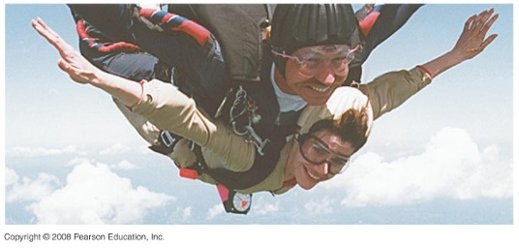

1. A rocket rises vertically, from rest, with an acceleration of  until it runs out of fuel at an altitude of 950 m. After this point, its acceleration is that of gravity, downward. (*a*) What is the velocity of the rocket when it runs out of fuel? (*b*) How long does it take to reach this point? (*c*) What maximum altitude does the rocket reach? (*d*) How much time (total) does it take to reach maximum altitude? (*e*) With what velocity does it strike the Earth? ( *f* ) How long (total) is it in the air?