1. Can cars “stop on a dime”? Calculate the acceleration of a 1400-kg car if it can stop from 35 kh on a dime () How many *g*’s is this? What is the force felt by the 68-kg occupant of the car?

2. A person stands on a bathroom scale in a motionless elevator. When the elevator begins to move, the scale briefly reads only 0.75 of the person’s regular weight. Calculate the acceleration of the elevator, and find the direction of acceleration.

3. Three blocks on a frictionless horizontal surface are in contact with each other as shown in figure below. A force  is applied to block A (mass ). (*a*) Draw a free-body diagram for each block. Determine (*b*) the acceleration of the system (in terms of  and ), (*c*) the net force on each block, and (*d*) the force of contact that each block exerts on its neighbor. (*e*) If  and  give numerical answers to (*b*), (*c*), and (*d*). Explain how your answers make sense intuitively.

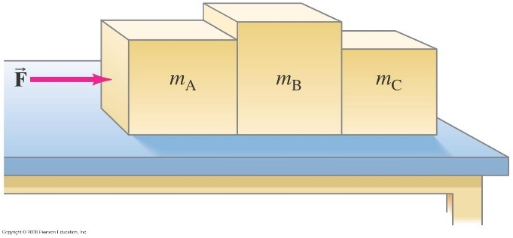

4. Energy use in the US (or the world) can be divided into three categories of roughly the same size. Name them.

5. Circle those units below (and only those units) which have dimensionality of energy .They need not be units that are commonly used or which we mentioned in class:

kW·hr hp J N

GJ lb Btu Quad

calorie N/m J ft·lb/s

W nN MW MTOE

6. List three greenhouse gases.

7. The power to a 1500W space heater in a dorm room is left on for three months during the winter.

a) Calculate the electrical energy consumed by the heater, in both kW•hr and Btu.

b) In NY state, residential customers pay nearly $0.18/kW•hr. Calculate the power bill (in dollars) for this space heater for three months. (Notice that the money wasted by the heater is about 2/3 of this value, if we assume electricity to be about 3´ as expensive as whatever primary fuel is used in heating the dorms.)

8. A catalytic converter does a number of things with automotive exhaust, including oxidizing unburned hydrocarbons. Let’s consider octane, C8H18, which the catalyst combines with oxygen, O2, to form carbon dioxide, CO2, and water vapor, H2O.(15 pts)

1. 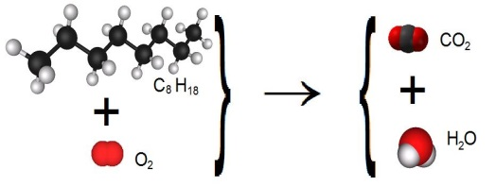Show the chemical reaction that occurs in this example, balancing the two sides.

b) Given that the atomic weights of carbon, hydrogen and oxygen are 12, 1, and 16, respectively, find the molecular weights of octane and carbon dioxide.

1. Show that burning one pound of octane releases about 3.1 pounds of carbon dioxide into the air.

9. The position of a particular particle as a function of time is given by  Determine the particle’s velocity and acceleration as a function of time.

10.

(*a*) A skier is accelerating down a 30.0° hill at  (Fig. 3–39). What is the vertical component of her acceleration? (*b*) How long will it take her to reach the bottom of the hill, assuming she starts from rest and accelerates uniformly, if the elevation change is 325 m?

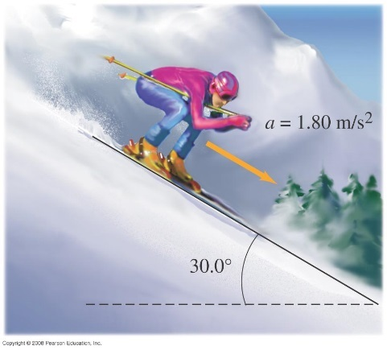

11. A baseball is seen to pass upward by a window 23 m above the street with a vertical speed of 14 ms. If the ball was thrown from the street, (*a*) what was its initial speed, (*b*) what altitude does it reach, (*c*) when was it thrown, and (*d*) when does it reach the street again?

12. Roger sees water balloons fall past his window. He notices that each balloon strikes the sidewalk 0.83 s after passing his window. Roger’s room is on the third floor, 15 m above the sidewalk. (*a*) How fast are the balloons traveling when they pass Roger’s window? (*b*) Assuming the balloons are being released from rest, from what floor are they being released? Each floor of the dorm is 5.0 m high.