**Problem 1.** If you were to travel to a star 135 light-years from Earth at a speed of 2.80 $×{10}^{8}m/s$ what would you measure this distance to be?

The measured distance is the contracted length. Use Eq. 36-3a.



**Problem 2.** A certain star is 18.6 light-years away. How long would it take a spacecraft traveling 0.950*c* to reach that star from Earth, as measured by observers: (*a*) on Earth, (*b*) on the spacecraft? (*c*) What is the distance traveled according to observers on the spacecraft? (*d*) What will the spacecraft occupants compute their speed to be from the results of (*b*) and (*c*)?

(*a*) To an observer on Earth, 18.6 ly is the rest length, so the time will be the distance divided by

the speed.



(*b*) The time as observed on the spacecraft is shorter. Use Eq. 36-1a.



(*c*) To the spacecraft observer, the distance to the star is contracted. Use Eq. 

(*d*) To the spacecraft observer, the speed of the spacecraft is their observed distance divided by

their observed time.



**Problem 3.** Suppose a news report stated that starship *Enterprise* had just returned from a 5-year voyage while traveling at 0.74*c*. (*a*) If the report meant 5.0 years of *Earth time*, how much time elapsed on the ship? (*b*) If the report meant 5.0 years of *ship time*, how much time passed on Earth?

(*a*) In the Earth frame, the clock on the *Enterprise* will run slower. Use Eq. 36-1a.



(*b*) Now we assume the 5.0 years is the time as measured on the *Enterprise*. Again use 

**Problem 4.** A spaceship passes you at a speed of 0.850*c*. You measure its length to be 38.2 m. How long would it be when at rest?

You measure the contracted length. Find the rest length from Eq. 36-3a.



**Problem 5.**  An observer on Earth sees an alien vessel approach at a speed of 0.60*c*. The *Enterprise* comes to the rescue (Fig. below), overtaking the aliens while moving directly toward Earth at a speed of 0.90*c* relative to Earth. What is the relative speed of one vessel as seen by the other?

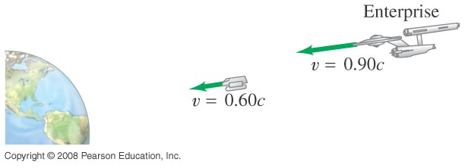

We take the positive direction in the direction of the *Enterprise*. Consider the alien vessel as reference frame S, and the Earth as reference frame  The velocity of the Earth relative to the alien vessel is  The velocity of the *Enterprise* relative to the Earth is  Solve for the velocity of the *Enterprise* relative to the alien vessel,  using Eq..



We could also have made the *Enterprise* as reference frame S, with  and the velocity of the alien vessel relative to the Earth as  The same answer would result.

Choosing the two spacecraft as the two reference frames would also work. Let the alien vessel be reference frame S, and the *Enterprise* be reference frame  Then we have the velocity of the Earth relative to the alien vessel as  and the velocity of the Earth relative to the *Enterprise* as  We solve for *v*, the velocity of the *Enterprise* relative to the alien vessel.

