**PHYS 301 Modern Physics**

**Exam 2 review**

**Wave Nature of Matter**

**40**. Calculate the wavelength of a 0.23-kg ball traveling at 0.140m/s

We find the wavelength from Eq. 37-7.



**41.** What is the wavelength of a neutron traveling at 8.5 10 4m/s

The neutron is not relativistic, so we can use  We also use



**42.** Through how many volts of potential difference must an electron be accelerated to achieve a wavelength of 0.21 nm?

We assume the electron is non-relativistic, and check that with the final answer. We use



Our use of classical expressions is justified. The kinetic energy is equal to the potential energy change.



Thus the required potential difference is 34 V.

**44.** The speed of an electron in a particle accelerator is 0.98c. Find its de Broglie wavelength. (Use relativistic momentum.)

We use the relativistic expression for momentum,



**47.** An electron has a de Broglie wavelength (a) What is its momentum? (b) What is its speed? (c) What voltage was needed to accelerate it to this speed?

(*a*) We find the momentum from :



(*b*) We assume the speed is non-relativistic.



Since  our assumption is valid.

(*c*) We calculate the kinetic energy classically.



This is the energy gained by an electron if accelerated through a potential difference of 4.2 V.

**48.**What is the wavelength of an electron of energy (a) 20 eV, (b) 200 eV, (c) 2.0 keV?

Because all of the energies to be considered are much less than the rest energy of an electron, we can use non-relativistic relationships. We use Eq. 37-7 to calculate the wavelength.



(*a*) 

(*b*) 

(*c*) 

**Uncertainty principle**

**4.** (I) An electron remains in an excited state of an atom for typically 10-8 s. What is the minimum uncertainty in the energy of the state (in eV)?

The minimum uncertainty in the energy is found :



**5.** (I) If an electron’s position can be measured to a precision of 2.6 X 10-8m how precisely can its speed be known?

The uncertainty in position is given. Use Eq. 38-1 to find the uncertainty in the momentum.



**6.** (I) The lifetime of a typical excited state in an atom is about 10ns. Suppose an atom falls from one such excited state and emits a photon of wavelength about 500 nm. Find the fractional energy uncertainty ΔE/E and wavelength uncertainty Δλ/λ of this photon.

The uncertainty in the energy is found from the lifetime and the uncertainty principle.





The wavelength uncertainty is the absolute value of this expression, and so 

**7.** (I) A radioactive element undergoes an alpha decay with a lifetime of 12μs. If alpha particles are emitted with 5.5-keV kinetic energy, find the uncertainty ΔE/E in the particle energy.

7. The uncertainty in the energy is found from the lifetime and the uncertainty principle.



**8.** (II) A 12-g bullet leaves a rifle horizontally at a speed of  (*a*) What is the wavelength of this bullet? (*b*) If the position of the bullet is known to a precision of 0.65 cm (radius of the barrel), what is the minimum uncertainty in its vertical momentum?

8. (*a*) We find the wavelength from Eq. 37-7.



(*b*) Use Eq. 38-1 to find the uncertainty in momentum



**9.** (II) An electron and a 140-g baseball are each traveling  measured to a precision of 0.085*%*. Calculate and compare the uncertainty in position of each.

9. The uncertainty in the position is found from the uncertainty in the velocity and Eq. 38-1.



The uncertainty for the electron is greater by a factor of 

**10.** (II) What is the uncertainty in the mass of a muon  specified in  given its lifetime of 2.20μs?

10. We find the uncertainty in the energy of the muon from Eq. 38-2, and then find the uncertainty in the

mass.



**11.** (II) A free neutron (m=1.6710-27kg) has a mean life of 900s. What is the uncertainty in its mass (in kg)?

11. We find the uncertainty in the energy of the free neutron from Eq. 38-2, and then the mass uncertainty from Eq. 36-12. We assume the lifetime of the neutron is good to two significant figures. The current experimental lifetime of the neutron is 886 seconds, so the 900 second value is certainly good to at least 2 significant figures.



**12.** (II) Use the uncertainty principle to show that if an electron were present in the nucleus

(r10-15 m) its kinetic energy (use relativity) would be hundreds of MeV. (Since such electron energies are not observed, we conclude that electrons are not present in the nucleus.) [*Hint*: Assume a particle can have energy as large as its uncertainty.]

12. Use the radius as the uncertainty in position for the electron. We find the uncertainty in the momentum from Eq. 38-1, and then find the energy associated with that momentum from Eq. 36-13.



If we assume that the lowest value for the momentum is the least uncertainty, we can estimate the lowest possible energy.



**13.** (II) An electron in the  state of hydrogen remains there on average about 10-8 s before jumping to the  state. (*a*) Estimate the uncertainty in the energy of the  state. (*b*) What fraction of the transition energy is this? (*c*) What is the wavelength, and width (in nm), of this line in the spectrum of hydrogen?

13. (*a*) The minimum uncertainty in the energy is found from Eq. 38-2.



(*b*) The transition energy can be found from Eq. 37-14b. *Z* = 1 for hydrogen.



(*c*) The wavelength is given by Eq. 37-3.



Take the derivative of the above relationship to find 



**14.** (II) How accurately can the position of a 3.50-keV electron be measured assuming its energy is known to 1.00*%*?

14. We assume the electron is non-relativistic. The momentum is calculated from the kinetic energy, and the position uncertainty from the momentum uncertainty, Eq. 38-1. Since the kinetic energy is known to 1.00%, we have 



**15.** (III) In a double-slit experiment on electrons (or photons), suppose that we use indicators to determine which slit each electron went through. These indicators must tell us the *y* coordinate to within *d*/2, where *d* is the distance between slits. Use the uncertainty principle to show that the interference pattern will be destroyed. [*Note*: First show that the angle  between maxima and minima of the interference pattern is given by $\frac{1}{2} λ/d$ [ Fig. below.]

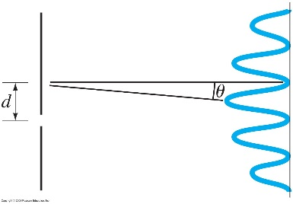

15. Let us assume that the electron has an initial *x* momentum  so that it has a wavelength of  The maxima of the double-slit interference pattern occur at locations satisfying Eq. 34-2a,  If the angles are small, then we replace  by , and so the maxima are given by  The angular separation of the maxima is then  and the angular separation between a maximum and the adjacent minimum is  The separation of a maximum and the adjacent minimum on the screen is then  where  is the distance from the slits to the detection screen. This means that many electrons hit the screen at a maximum position, and very few electrons hit the screen a distance  to either side of that maximum position.

If the particular slit that an electron passes through is known, then  for the electrons at the location of the slits is  The uncertainty principle says  We assume that  for the electron must be at least that big. Because of this uncertainty in *y* momentum, the electron has an uncertainty in its location on the screen, as  Since this is about the same size as the separation between maxima and minima, the interference pattern will be “destroyed.” The electrons will not be grouped near the maxima locations. They will instead be “spread out” on the screen, and no interference pattern will be visible.

**Bohr Model**

**55.** (I) How much energy is needed to ionize a hydrogen atom in the  state?

To ionize the atom means removing the electron, or raising it to zero energy.



**56.** (I) (*a*) Determine the wavelength of the second Balmer line ( to  transition) using Fig. 2. Determine likewise (*b*) the wavelength of the third Lyman line and (*c*) the wavelength of the first Balmer line.

We use the equation that appears above Eq. 37-15 in the text.

(*a*) The second Balmer line is the transition from *n* = 4 to *n* = 2.



(*b*) The third Lyman line is the transition from *n* = 4 to *n* = 1.



(*c*) The first Balmer line is the transition from *n* = 3 to *n* = 2.

For the jump from *n* = 5 to *n* = 2, we have



**57.** (I) Calculate the ionization energy of doubly ionized lithium, Li 2+ which has 

Doubly ionized lithium is similar to hydrogen, except that there are three positive charges (*Z* = 3) in the nucleus. The square of the product of the positive and negative charges appears in the energy term for the energy levels. We can use the results for hydrogen, if we replace *e*2 by *Ze*2:





**59.** (II) What is the longest wavelength light capable of ionizing a hydrogen atom in the ground state?

The longest wavelength corresponds to the minimum energy, which is the ionization energy:



**60.** (II) In the Sun, an ionized helium (He +) atom makes a transition from the  state to the  state, emitting a photon. Can that photon be absorbed by hydrogen atoms present in the Sun? If so, between what energy states will the hydrogen atom transition occur?

Singly ionized helium is like hydrogen, except that there are two positive charges (*Z* = 2) in the nucleus. The square of the product of the positive and negative charges appears in the energy term for the energy levels. We can use the results for hydrogen, if we replace *e*2 by *Ze*2.



We find the energy of the photon from the *n* = 5 to *n* = 2 transition in singly-ionized helium.



Because this is NOT the energy difference between any two specific energy levels for hydrogen, the photon CANNOT be absorbed by hydrogen.

**61.** (II) What wavelength photon would be required to ionize a hydrogen atom in the ground state and give the ejected electron a kinetic energy of 20.0 eV?

The energy of the photon is the sum of the ionization energy of 13.6 eV and the kinetic energy of 20.0eV. The wavelength is found from Eq. 37-3.



**62.** (II) For what maximum kinetic energy is a collision between an electron and a hydrogen atom in its ground state definitely elastic?

A collision is elastic if the kinetic energy before the collision is equal to the kinetic energy after the collision. If the hydrogen atom is in the ground state, then the smallest amount of energy it can absorb is the difference in the *n* = 1 and *n* = 2 levels. So as long as the kinetic energy of the incoming electron is less than that difference, the collision must be elastic.



**63.** (II) Construct the energy-level diagram for the ion He + (like Fig.2).

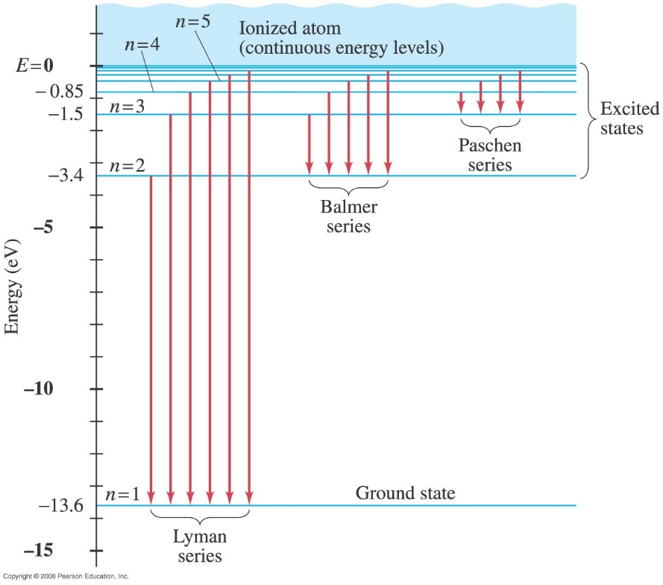

**Fig. 2**

Singly ionized helium is like hydrogen, except that there are two positive charges (*Z* = 2) in the nucleus. The square of the product of the positive and negative charges appears in the energy term for the energy levels. We can use the results for hydrogen, if we replace *e*2 by *Ze*2:



**64.** (II) Construct the energy-level diagram (like Fig. 2) for doubly ionized lithium, Li 2+ .

Doubly ionized lithium is like hydrogen, except that there are

three positive charges (*Z* = 3) in the nucleus. The square of the product of the positive and negative charges appears in the energy term for the energy levels. We can use the results for hydrogen, if we replace *e*2 by *Ze*2:





**65.** (II) Determine the electrostatic potential energy and the kinetic energy of an electron in the ground state of the hydrogen atom.

The potential energy for the ground state is given by the charge of the electron times the electric potential caused by the proton.



The kinetic energy is the total energy minus the potential energy.



**66.** (II) An excited hydrogen atom could, in principle, have a diameter of 0.10 mm. What would be the value of *n* for a Bohr orbit of this size? What would its energy be?

The value of *n* is found from  and then find the energy from Eq. 37-14b.

