PHYS 212L Wave Phenomena Name:__________________

Partner(s):__________________________

**Purpose:** Determine the wavelength of light using wave phenomena.

Watch the following video:

<https://www.youtube.com/watch?v=nuaHY5lj2AA>

**A. Diffraction Grating**

Theory: (From Halliday, Resnick, and Walker, 9th Ed, Chapter 36-8)

One of the most useful tools in the study of light and of objects that emit and absorb light is the **diffraction grating**. This device has a number *N* of slits, often called *rulings*, perhaps as many as several thousand per millimeter. An idealized grating consisting of only five slits is represented in Fig. [36-18](http://edugen.wiley.com/edugen/courses/crs4957/halliday9118/halliday9088c36/halliday9118/halliday9088c36/halliday9088c36xlinks.xform?id=halliday9088c36-fig-0018). When monochromatic light is sent through the slits, it forms narrow interference fringes that can be analyzed to determine the wavelength of the light.

|  |  |  |  |  |  |  |  |  |  |  |  |  |  |  |
| --- | --- | --- | --- | --- | --- | --- | --- | --- | --- | --- | --- | --- | --- | --- |
| http://edugen.wiley.com/edugen/courses/crs4957/common/art/pixel.gif | |  | | --- | | http://edugen.wiley.com/edugen/courses/crs4957/common/art/pixel.gif | | |  |  |  |  | | --- | --- | --- | --- | | |  | | --- | | http://edugen.wiley.com/edugen/courses/crs4957/common/art/pixel.gif | | http://edugen.wiley.com/edugen/courses/crs4957/halliday9118/halliday9088c36/image_n/nt0020-y.gif | | http://edugen.wiley.com/edugen/courses/crs4957/common/art/pixel.gif | | | | http://edugen.wiley.com/edugen/courses/crs4957/common/art/pixel.gif | | |  |  |  | | --- | --- | --- | | [Figure zoom](http://edugen.wiley.com/edugen/courses/crs4957/halliday9118/halliday9088c36/halliday9118/halliday9088c36/halliday9088c36xlinks.xform?id=halliday9088c36-fig-0018) | **Figure 36-18** | An idealized diffraction grating, consisting of only five rulings, that produces an interference pattern on a distant viewing screen *C*. | | | http://edugen.wiley.com/edugen/courses/crs4957/common/art/pixel.gif | | http://edugen.wiley.com/edugen/courses/crs4957/common/art/pixel.gif |

With monochromatic light incident on a diffraction grating, if we gradually increase the number of slits, the intensity plot changes to a simple graph like that shown in Fig. [36-19](http://edugen.wiley.com/edugen/courses/crs4957/halliday9118/halliday9088c36/halliday9118/halliday9088c36/halliday9088c36xlinks.xform?id=halliday9088c36-fig-0019)*a*. The pattern you would see on a viewing screen using monochromatic red light from, say, a helium-neon laser is shown in Fig. [36-19](http://edugen.wiley.com/edugen/courses/crs4957/halliday9118/halliday9088c36/halliday9118/halliday9088c36/halliday9088c36xlinks.xform?id=halliday9088c36-fig-0019)*b*. The maxima are now very narrow (and so are called *lines*); they are separated by relatively wide dark regions.

|  |  |  |  |  |  |  |  |  |  |  |  |  |  |  |
| --- | --- | --- | --- | --- | --- | --- | --- | --- | --- | --- | --- | --- | --- | --- |
| http://edugen.wiley.com/edugen/courses/crs4957/common/art/pixel.gif | |  | | --- | | http://edugen.wiley.com/edugen/courses/crs4957/common/art/pixel.gif | | |  |  |  |  | | --- | --- | --- | --- | | |  | | --- | | http://edugen.wiley.com/edugen/courses/crs4957/common/art/pixel.gif | | http://edugen.wiley.com/edugen/courses/crs4957/halliday9118/halliday9088c36/image_n/nt0021-y.gif | | http://edugen.wiley.com/edugen/courses/crs4957/common/art/pixel.gif | | | | http://edugen.wiley.com/edugen/courses/crs4957/common/art/pixel.gif | | |  |  |  | | --- | --- | --- | | [Figure zoom](http://edugen.wiley.com/edugen/courses/crs4957/halliday9118/halliday9088c36/halliday9118/halliday9088c36/halliday9088c36xlinks.xform?id=halliday9088c36-fig-0019) | **Figure 36-19** | (*a*) The intensity plot produced by a diffraction grating with a great many rulings consists of narrow peaks, here labeled with their order numbers *m.(b*) The corresponding bright fringes seen on the screen are called lines and are here also labeled with order numbers *m*. | | | http://edugen.wiley.com/edugen/courses/crs4957/common/art/pixel.gif | | http://edugen.wiley.com/edugen/courses/crs4957/common/art/pixel.gif |

We use a familiar procedure to find the locations of the bright lines on the viewing screen. We first assume that the screen is far enough from the grating so that the rays reaching a particular point *P* on the screen are approximately parallel when they leave the grating (Fig. [36-20](http://edugen.wiley.com/edugen/courses/crs4957/halliday9118/halliday9088c36/halliday9118/halliday9088c36/halliday9088c36xlinks.xform?id=halliday9088c36-fig-0020)). Then we apply to each pair of adjacent rulings the same reasoning we used for double-slit interference. The separation *d* between rulings is called the *grating spacing*. (If *N* rulings occupy a total width *w*, then *d* = *w/N*.) The path length difference between adjacent rays is again *d* sin *θ* (Fig. [36-20](http://edugen.wiley.com/edugen/courses/crs4957/halliday9118/halliday9088c36/halliday9118/halliday9088c36/halliday9088c36xlinks.xform?id=halliday9088c36-fig-0020)), where *θ* is the angle from the central axis of the grating (and of the diffraction pattern) to point *P*. A line will be located at *P* if the path length difference between adjacent rays is an integer number of wavelengths—that is, if

|  |  |
| --- | --- |
| http://edugen.wiley.com/edugen/courses/crs4957/common/art/pixel.gif | |
| |  |  |  |  |  |  | | --- | --- | --- | --- | --- | --- | | http://edugen.wiley.com/edugen/courses/crs4957/common/art/pixel.gif | |  | | --- | | http://edugen.wiley.com/edugen/courses/crs4957/common/art/pixel.gif | | http://edugen.wiley.com/edugen/courses/crs4957/halliday9118/halliday9088c36/image_n/nt0060-y.gif | | http://edugen.wiley.com/edugen/courses/crs4957/common/art/pixel.gif | | http://edugen.wiley.com/edugen/courses/crs4957/common/art/pixel.gif | | (36-25) |
| http://edugen.wiley.com/edugen/courses/crs4957/common/art/pixel.gif | |

where *λ* is the wavelength of the light. Each integer *m* represents a different line; hence these integers can be used to label the lines, as in figure below. The integers are then called the *order numbers*, and the lines are called the zeroth-order line (the central line, with *m* = 0), the first-order line (*m* = 1), the second-order line (*m* = 2), and so on.

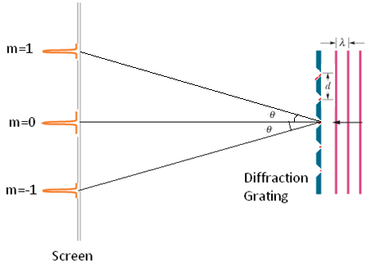

Apparatus: Diffraction grating (500 lines/mm), meter stick-2, and laser w/power adapter.

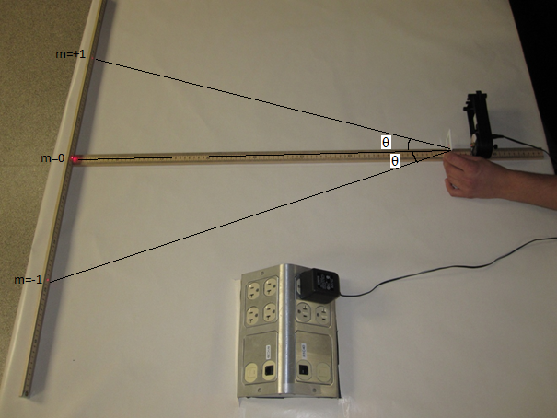 Figure 1

Procedure:  
1. Place a meter-stick on the side, parallel to the edge of the lab-table, place the other meter-stick flat, perpendicular to the first meter stick, as shown above.

2. Place the diode-laser on the side on top of the flat-meter stick.

3. Turn on the laser and adjust it until the laser beam strikes the middle of the scale.

4. Hold the diffraction grating (500 lines/mm) in the path of the laser beam and obtain the first order diffraction spots (m=1 and m=-1) on the scale of the meter-stick.

5. Make the necessary measurements and calculate the wavelength.  
6. List the accepted value, and find the %Error.

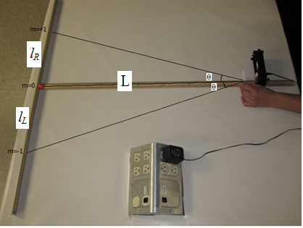 Figure 2

DATA:

d = (1/500) mm = ________mm = ________nm Center spot location = _________

|  |  |  |  |  |  |  |
| --- | --- | --- | --- | --- | --- | --- |
| L (cm) | *lR* (cm) | *lL* (cm) | θ | Sin θ | λ= d Sinθ | |
| 90 |  |  |  |  |  | |
| 80 |  |  |  |  |  | |
| 70 |  |  |  |  |  | |
| 60 |  |  |  |  |  | |
| Average λ | | | | | |  |
| Accepted λ | | | | | |  |
| % Error | | | | | |  |

Show the calculation of the wavelength λ

**B. Simulation on Interference of light**  
Go to the following simulation: <https://www.geogebra.org/m/ZSbeWGbe>

|  |
| --- |
|  |
|  |
|  |

1. What you see is the double slit interference pattern with diffraction superimposed. Write down the following simulation parameters:   
Wavelength, λ =______________________Single-Slit Width, a = ___________  
Double-Slit separation, d = _____________Slit to screen distance, D =___________

2. Change each of the above parameters and find out, what parameter is the interference pattern independent of? ______________________

3. Change each of the above parameters and find out, what parameter is the diffraction pattern independent of? ______________________

4. Describe what happens to the fringe width (Z) of the double-slit interference pattern as you change the following:  
  
i. Wavelength (λ): directly proportional or inversely proportional  
ii. Slit to screen distance (D): directly proportional or inversely proportional  
iii. Slit-separation (d): directly proportional or inversely proportional  
iv. Deduce an equation for Z (fringe-width) using the above observation and a proportionality constant of 1.   
 Z =  
5. Describe what happens to the half-width (Y) of the central diffraction pattern as you change the following:  
  
i. Wavelength (λ): directly proportional or inversely proportional  
ii. Single-Slit-width (a): directly proportional or inversely proportional  
iii. Slit to screen distance (D): directly proportional or inversely proportional   
iv. Deduce an equation for Y (half-width) using the above observation and a proportionality constant of 1.   
 Y =

**C. Experiments: Single-Slit**

Theory:

|  |  |
| --- | --- |
| F27.23 | F27.24 |

For the first dark fringe (y is the half-width of the central dark fringe, a is the single-slit width, and λ is wavelength): $a\sin{θ}=λ$ 
 or $a\sin{θ}=λ=a\sin{θ ≈a\tan{θ}}$ = a $\frac{Y}{L}$ $Y=λL/a$ 
   
        or $λ=aY/L$

Apparatus: Light sensor with aperture bracket, diode laser, single-slit set, optics bench, rotary motion sensor, linear translator, meter stick, 850-interface, and PC.

Procedure:

1. The optics bench w/linear translator/light sensor and rotary motion sensor is on the lab table.   
     
   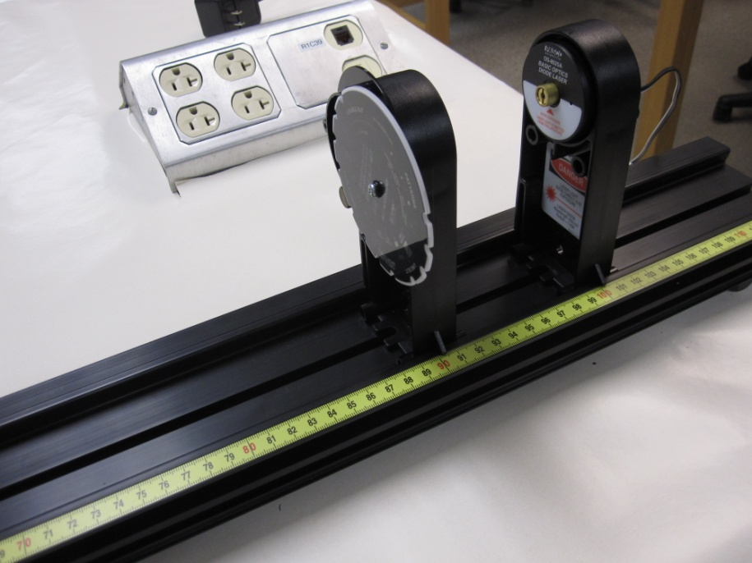

Figure 2

2. Mount the diode laser on the other far-end, at the 115-cm mark of the optics bench (Figure 2).

3. Mount the single-slit set to slit-width, a = 0.16 mm, at the 105-cm mark.

4. Plug in the power adapter for the laser.

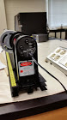

5. Connect the rotary motion sensor to digital channels 1 (black) and 2 (yellow).

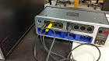  
  
6. Connect the light sensor to analog input A, and set the gain to 100.

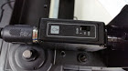

7. Adjust the position of the light sensor laser (with the two screws on the back of the Diode) so that the laser beam strikes in the middle of the aperture bracket-1.   
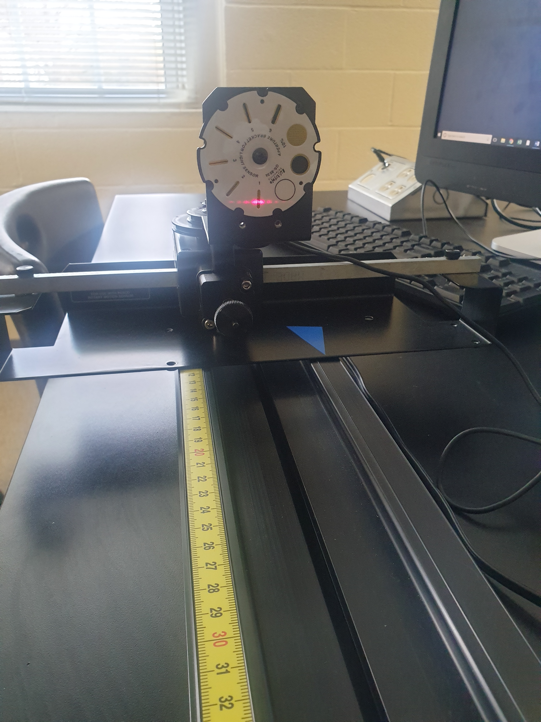  
8. Move the rotary motion sensor/light sensor so that the interference pattern is away from aperture bracket-1.

9. Setting up the Interface:   
a. Make sure that the power for the interface is turned on.  
b. Open **PASCO Capstone** software from the desktop.   
c. Click **File** (top-left corner), click **Open Experiment**, click the drop-down menu for **Files of type**, and choose **DataStudio 1.9 files**, open **P35_Diffraction.ds** from desktop, and OK **USB 850 interface.**d. Click **Data Summary**, on the left column, click **Position** under Rotary Motion sensor, click the **gear** symbol for position, click **Numerical Format**, change the **Number of Decimal** places to 5, click OK, and close **Data Summary**, by clicking it.  
e. Change the Sample Rate (in the bottom) to 200 Hz.   
10. Click Record, and slowly and smoothly move the rotary/light sensor so that the whole pattern passes through the sensor.   
11. Stop recording data and maximize the graph display.   
12. Click on the **Show coordinates tool** (8th from left), measure the width of the central bright fringe (2Y), single-slit to screen distance (L) with a meter stick, and complete the data table.   
13. Attach a copy of the diffraction pattern.   
  
DATA

|  |  |  |  |  |
| --- | --- | --- | --- | --- |
| Single-slit width  a (mm) | Width of Central Bright Fringe 2Y (m) | Half-Width of Central Bright Fringe  Y (m) | Single slit-Screen distance L ( ) | λ  (λ = aY/L) |
| 0.16 |  |  |  |  |
| 0.08 |  |  |  |  |
| 0.04 |  |  |  |  |
| Average λ | | | |  |
| Accepted λ | | | |  |
| % Error | | | |  |

**D. Double-Slit Interference**

*Instructor Notes: Attach the linear translator to the optics bench close to the 0-cm end, attach the rotary motion sensor, and set the aperture bracket to 1.*

Theory: Watch the video mini-lecture “Two-Slit Interference”, in Chapter 35, WileyPlus.

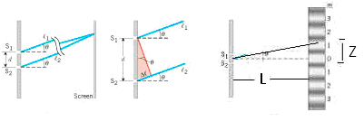

Bright fringes of a double-slit are given by (d is double-slit separation and λ is wavelength),



First bright fringe is given by,



$Z=λL/d$ or $λ=dZ/L$; (Z is fringe-width),

Apparatus: Light sensor w/aperture bracket & cable, diode laser w/power adapter, multiple-slit set, optics bench w/linear translator, meter stick, rotary motion sensor, 850-interface, and PC.

Procedure:

1. Set the multiple slit to a double slit separation, d = 0.25 mm and a = 0.04 mm, and place it at the 90-cm mark.     
  
2. Move the rotary motion sensor/light sensor so that the interference pattern is away from aperture bracket-1.   
  
3. Click **Record**, and slowly and smoothly move the rotary/light sensor so that the whole interference pattern passes through aperture-1 of the light sensor.   
  
4. Stop recording data and maximize the graph display.  
  
5. Measure the total width for multiple fringes, double-slit to screen distance (L) with a meter stick, and complete the data table.   
  
6. Attach a copy of the interference pattern.

DATA

|  |  |  |  |  |  |
| --- | --- | --- | --- | --- | --- |
| Double-slit separation  d (mm) | Number of Fringes  N | Total Width (m) | Fringe Width Z (m) | Double slit-Screen distance L ( ) | λ  (λ = dZ/L) |
| 0.25 |  |  |  |  |  |
| 0.50 |  |  |  |  |  |
| Average λ | | | | |  |
| Accepted λ | | | | |  |
| % Error | | | | |  |

**E. Conclusion:**

Write a conclusion for part C and D