PHYS212 Spherical mirrors and lenses
Name:_____________________________
Partner(s):_______________________________________________________________
Watch the following video: https://www.youtube.com/watch?app=desktop&v=c6mLLaqLdvg

Theory: For a spherical mirror or thin lens, the focal length (f) is given by (d_{o} = object distance, d_{i} = image distance):
Magnification, m is given by the following equations; (Si = image size, So = object size).
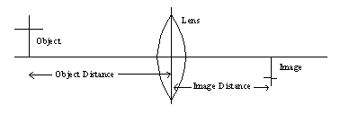
The object distance is from the object to the lens or mirror and the image distance is from the image to the lens or mirror.
Make a sketch of the following lenses & mirrors below:
Convex Lens | Concave Lens | Plane Mirror | Concave Mirror | Convex Mirror

Sign Convention
Object & Image distances------> | Real--------> (+) | Virtual------> (-)
Focal Lengths----------> | Convex lens & Concave mirror----> (+) | Concave lens & Convex mirror----> (-)

Draw rays to locate images for the following 4 cases. Help: Converging Lens, Diverging Lens.
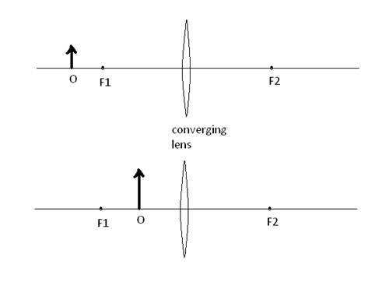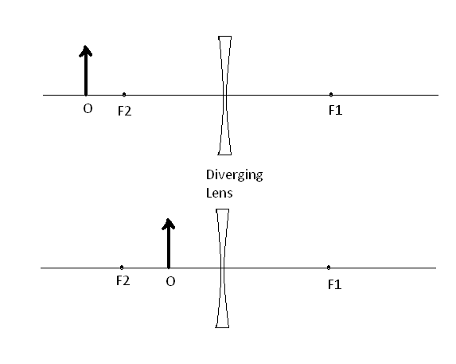
A. Purpose: Investigate the difference between a convex lens and a concave lens in forming real images.
Apparatus: Optical bench and accessories w/translucent screen, convex lens (f = 5 cm), and concave lens.
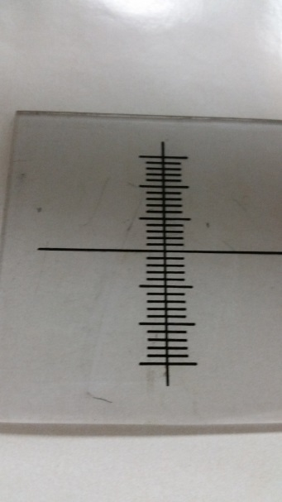 Translucent screen
Procedure: The light bulb is placed next to the object to illuminate it. Put the convex lens in the lens holder and place it in the optical bench so that the object distance is 10 cm. Move the screen and see whether you get a real image on the screen. Repeat the above procedure for other object distances and for the concave lens.
The lens focal length can be checked with a ruler and a white piece of paper under the light as shown in the picture:
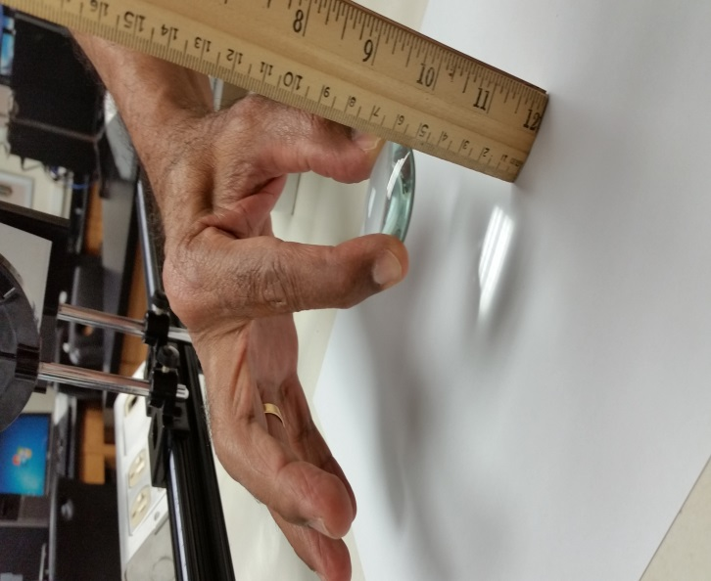

Data:
Object Distance (cm) | For convex lens (f =5 cm), Real image YES/NO | For concave lens,  Real image YES/NO
10 | - | -
20 | - | -
30 | - | -
40 | - | -
50 | - | -
60 | - | -
Results (summarized):
B. Purpose: For convex lenses, investigate and find out the range of object distances for which there are real images, and predict a correlation between the focal length and object distances for real images.
Apparatus: Optical bench and accessories and convex lenses: f = 10, 15, 20, and 30 cm.
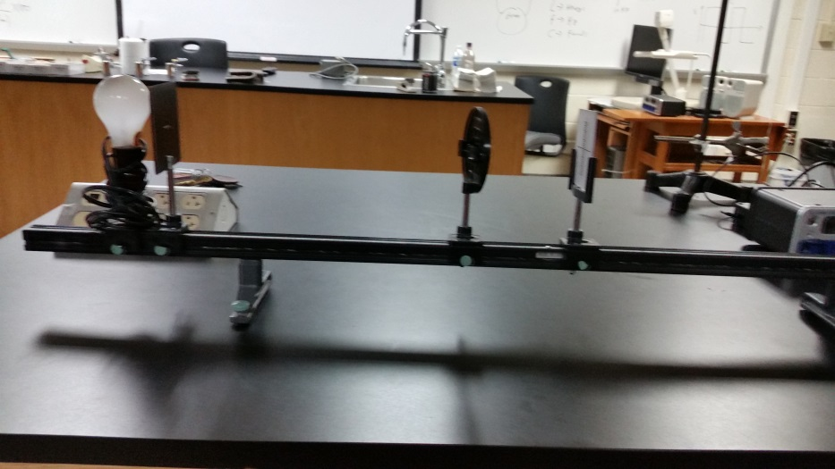
Mount the convex lens as shown:
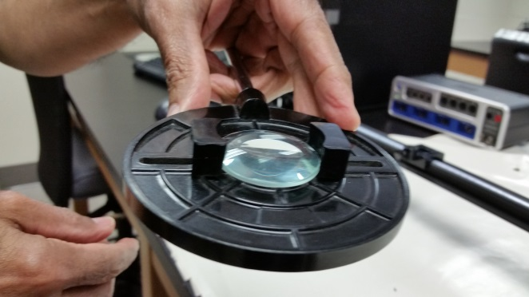
Make sure that the measuring scale or tape is at 0 as shown in the picture
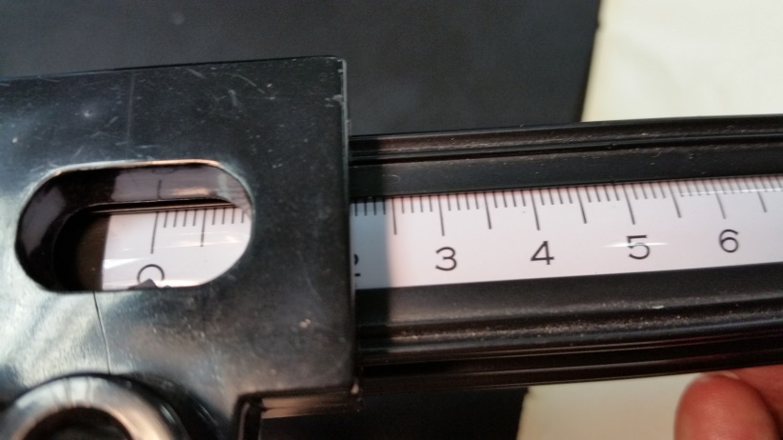

Data:
Object Distance (cm) | f = 10 cm,  Real image YES/NO | f = 15 cm,  Real image YES/NO | f = 20 cm,  Real image YES/NO | f = 30 cm,  Real image YES/NO
5 | - | - | - | -
10 | - | - | - | -
15 | - | - | - | -
20 | - | - | - | -
25 | - | - | - | -
30 | - | - | - | -
35 | - | - | - | -
40 | - | - | - | -
50 | - | - | - | -
60 | - | - | - | -
Results (summarized):

C. Purpose: To investigate the magnifications of real images formed by a convex lens and determine the focal length.
Apparatus: Convex lenses (f = 20 cm), optical bench & accessories, and foot ruler.
Procedure: Measure the object size. Place the 20-cm lens in the lens holder and set up the lens holder at 30 cm from the object. Move the screen and obtain a sharp image. Measure the image distance and the image size. Calculate the following: focal length, magnification using image size and object size, and magnification using image distance and object distance. Repeat your measurements for object distances 35 cm, 40 cm, 45 cm, 50 cm, 55 cm, and 60 cm.
DATA Object size = s_{o} = _____________
Object  Distance, d_{o}  (cm) | Image  Distance, d_{i}  ( ) | Image Size, S_{i}  ( ) | Focal Length, f  ( ) | Magnification, |m| = S_{i} /S_{o} | Magnification, | m| = d_{i} /d_{o}
30
35
40
45
50
55
60
Draw a ray diagram (Help) and show the formation of image for any one of the above cases.

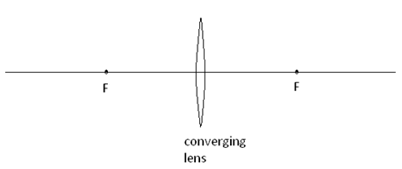
D. Purpose: To investigate the magnifications of real images formed by a concave mirror and determine the focal length.
Apparatus: Concave mirror, optical bench & accessories, opaque screen, and foot ruler.
Procedure: Measure the object size. Place the concave mirror in the mirror holder and set up the holder at 35 cm from the object. (You can move the measuring tape and measure the distance as shown);
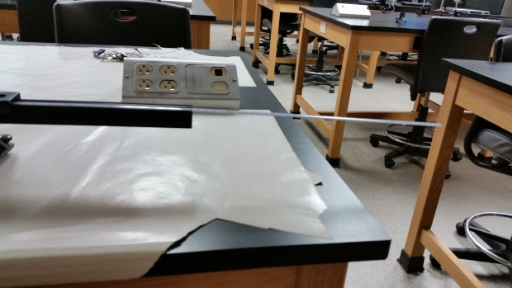
Replace the translucent screen with an opaque screen and place it between the object and mirror. Move the screen and obtain a sharp image. Measure the image distance and the image size. Calculate the following: focal length, magnification using image size and object size, and magnification using image distance and object distance. Repeat your measurements for object distances 35 cm, 40 cm, 45 cm, 50 cm, 55 cm, and 60 cm.
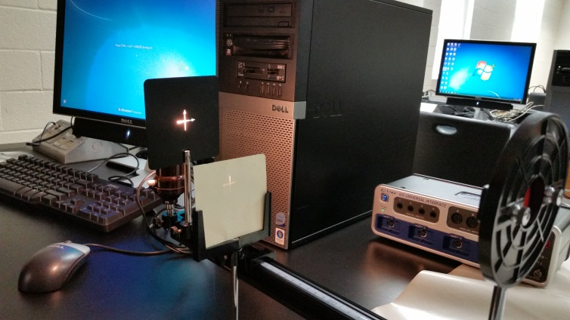
You will have to bend the mirror to obtain an image:
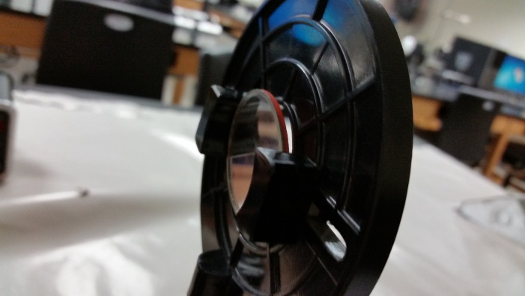
DATA Object size = s_{o} = _____________
Object  Distance, d_{o}  (cm) | Image  Distance, d_{i}  ( ) | Image Size, s_{i}  ( ) | Focal Length, f  ( ) | Magnification, |m| = s_{i} /s_{o} | Magnification, | m| = d_{i} /d_{o}
35
40
45
50
55
60
Draw a ray diagram (Help: concave mirror) and show the formation of image for any one of the above cases.
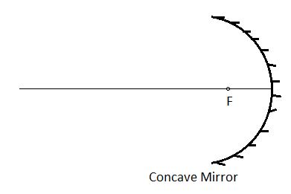

E. Conclusion

