**PHYS LAB** [**RESISTANCE**](http://hyperphysics.phy-astr.gsu.edu/hbase/electric/resis.html)                  Name:________________________

**Partner(s):_______________________________________________________________**  
  
**Purpose I:** To investigate the resistance of a metal wire using a [digital multi meter](http://www.youtube.com/watch?v=bF3OyQ3HwfU) (DMM) and determine its resistivity.

**Apparatus:** DMM, one long metal (nichrome) wire (≈100 cm), 2 C-clamps, 2 wood pieces, 2 mini hook test leads, micrometer, and meter stick.

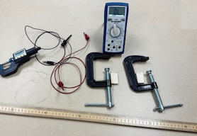

Theory: Resistance, R of a metal wire of length *L* and cross-sectional area *A* is given by:

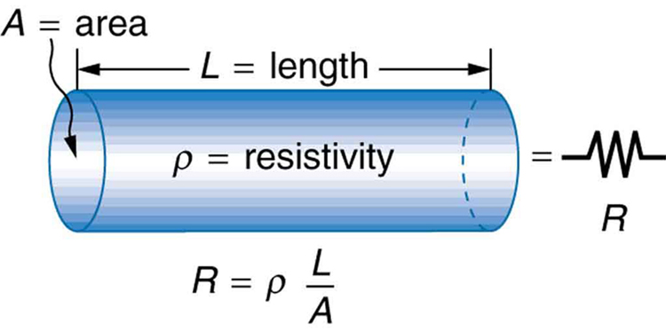                     
a. In the above equation, Identify the useful variables and constants to study the resistance as a function of length.

b. Identify the x-y scatter plot that can be used to determine resistivity.

**Procedure:**

**Variation of resistance with length:**

1. Clamp the 0-cm end of the meter stick with the nichrome wire on it and a wood piece on top of the wire with a C-clamp as shown below.
2. Clamp the 100-cm end of the meter stick with the nichrome wire on it and a wood piece on top of the wire with another C-clamp, while stretching the wire, as shown below.

|  |  |
| --- | --- |
|  |  |
| Figure for Procedure 1 | Figure for Procedure 2 |

1. Connect the mini hook of the black test lead at the 0-cm of the wire, the mini hook of the red test lead at the 10-cm of the wire, and connect the banana plug ends to the DMM.

|  |  |  |  |  |  |  |  |  |  |  |  |  |  |  |  |  |  |  |  |  |  |  |  |
| --- | --- | --- | --- | --- | --- | --- | --- | --- | --- | --- | --- | --- | --- | --- | --- | --- | --- | --- | --- | --- | --- | --- | --- |
|  | |  |  | | --- | --- | | L (cm) | R (ohm) | | 10 |  | | 20 |  | | 30 |  | | 40 |  | | 50 |  | | 60 |  | | 70 |  | | 80 |  | | 90 |  | | 100 |  | |

1. Set the DMM to measure resistance and measure the resistance for 10 cm of the wire.
2. Repeat the measurements for other lengths: 20, 30, 40, 50, 60, 70, 80, 90, 100 cm, by releasing the mini hook by pulling and sliding to the correct length.
3. Plot a graph, R versus L, determine its slope, and attach the graph to your report.
4. Measure the diameter of the wire with a micrometer, calculate the cross-sectional area, and calculate the resistivity of the metal.

**Variation of resistance with diameter:**

1. Fold the wire into half and then again half to make 4 equal pieces.  
   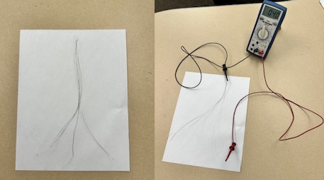
2. Measure the resistance of one-fold, two folds, three folds, and four folds.

|  |  |
| --- | --- |
| **Number of Folds** | **Resistance (Ohms)** |
|  |  |
|  |  |
|  |  |
|  |  |

1. Plot R versus the number of folds.
2. Add an appropriate fit to your graph and obtain the resistivity from your fit.
3. Attach your graph to the report.

DATA  
  
**Variation of resistance with length:**

Slope of the graph, R versus L:_______________

Diameter of wire = __________________    Cross-Sectional area of wire =________________

Experimental resistivity of wire = _________________

Accepted resistivity of wire = 1.10 x 10-4 ohm.cm. % Error = __________________

**Variation of resistance with diameter:**

Slope or Coefficient of the fit = _________________

Length of wire = __________________    Cross-Sectional area (for 1fold) =_______________

Experimental resistivity of wire = _________________

Accepted resistivity of wire = 1.10 x 10-4 ohm.cm. % Error = __________________

**Purpose II: To investigate various combinations of resistors.**

**Apparatus:** Three resistors, DMM (digital multimeter), and 5-banana plug wires.     
  
**Theory:**   
  
When two or more resistances are connected in series the equivalent resistance, RS is given by;

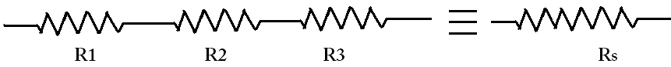                         

When two or more resistances are connected in parallel the equivalent resistance, RP is given   
by:



**Procedure:**  
1. Determine the values of the three resistors using [the resistor color code.](http://nearbus.net/wiki/index.php?title=File:Resistor_color_codes.jpg)       
2. Measure the values of the three resistors using the [digital multimeter](http://www.youtube.com/watch?v=bF3OyQ3HwfU) (DMM).

3. Observe the tolerance values and record them in the data table.

|  |  |  |  |
| --- | --- | --- | --- |
|  | R1 | R2 | R3 |
| From resistor color code |  |  |  |
| From digital multi- meter |  |  |  |
| Tolerance |  |  |  |

4. Connect R1 and R2 in series and measure the equivalent resistance. Also calculate it

5. Connect R1 and R2 in parallel and measure the equivalent resistance. Also calculate it.

R1, R2 in parallel

|  |  |  |
| --- | --- | --- |
| Diagram | Measured | Calculated |
| R1 and R2 in series: |  |  |
| R1 and R2 in parallel: |  |  |
| 6. Rank the values of R1, R2, R1 series R2, R1 parallel R2 in descending order: | | |

7. Connect the three resistors in various combinations and obtain various values of resistances. Measure the equivalent resistance. Also calculate the equivalent resistances using the measured values for R1, R2, and R3.

R1, R2, and R3 in series

8. Identify the lowest and highest resistance values in the table.

|  |  |  |
| --- | --- | --- |
| Resistor combination diagram | Resistance Values | |
| Measured | Calculated |
|  |  |  |
|  |  |  |
| R1 parallel R2 in series R3 |  |  |
| R2 parallel R3 in series R1 |  |  |
| R1 parallel R3 in series R2 |  |  |
| R1 in series R2 parallel R3 |  |  |
| R2 in series R3 parallel R1 |  |  |
| R1 in series R3 parallel R2 |  |  |

**Conclusion**