PHYS 212L METERS
Name:________________________ Partner:___________________________
Purpose: To measure the full scale current (I_{C}) and the internal coil resistance (R_{C}) of an analog meter and construct a voltmeter and an ammeter using this meter.
Apparatus: Meter, decade resistance box (999 KΩ), digital multi-meter (DMM), power supply, 89-ohm rheostat, connecting wires, meter stick, wire cutter, and # 35 Cu wire.
Theory: The essential parts of a dc analog meter are shown in Figure (a) below.
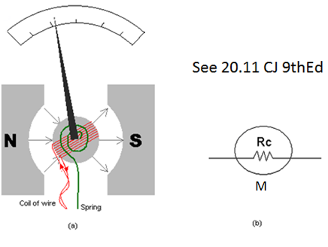
It consists of a magnet, a coil of wire, a spring, a pointer, and a calibrated scale. The coil is mounted in such a way that it can rotate, which causes the pointer to move in relation to the scale. The coil of wire and pointer rotate when there is a current in the wire. The coil rotates in response to the torque applied by the magnetic field when there is a current in the coil. The coil stops rotating when this torque is balanced by the torque of the spring.
A meter has two important characteristics that must be considered when it is used as part of a measurement device. First, the amount of dc current that causes a full-scale deflection (I_{C}) of the pointer indicates the sensitivity of the meter. The second important characteristic is the resistance R_{C} of the wire in the coil. Figure (b) above shows how a meter with a coil resistance of R_{C} is represented in a circuit diagram.
In this lab, first we will measure the full scale current (I_{C}) and the internal coil resistance (R_{C}) of a meter. Then we will construct and check a voltmeter and an ammeter.
Answer the following:
1. List 5 components of an analog meter.
2. What function is accomplished by the spring in an analog meter?
3. List two important characteristics of an analog meter.
4. Current can be measured with _________________________.
5. Potential difference or Voltage can be measured with _________________________.
6. A light bulb is connected to a battery. A voltmeter and an ammeter are used to measure the current through and the voltage across the bulb. Show this in a circuit diagram.

7. For the following questions answer high, infinity, low, or zero.
- The resistance of an ideal ammeter is __________________.
- The resistance of a good ammeter is ___________________.
- The resistance of an ideal voltmeter is __________________.
- The resistance of a good voltmeter is ___________________.

Procedure:
A) To measure the full-scale current (I_{C}) and the internal coil resistance (R_{C}):
- Check your decade box for their values and rheostat for its working condition by connecting to a DMM in the resistance mode.
- Keeping the red wire (+) unplugged, set up the following circuit. Use power supply (set to about 2 volt), decade resistance box (set to 999-Ω), and DMM as ammeter (set to 10A), and meter.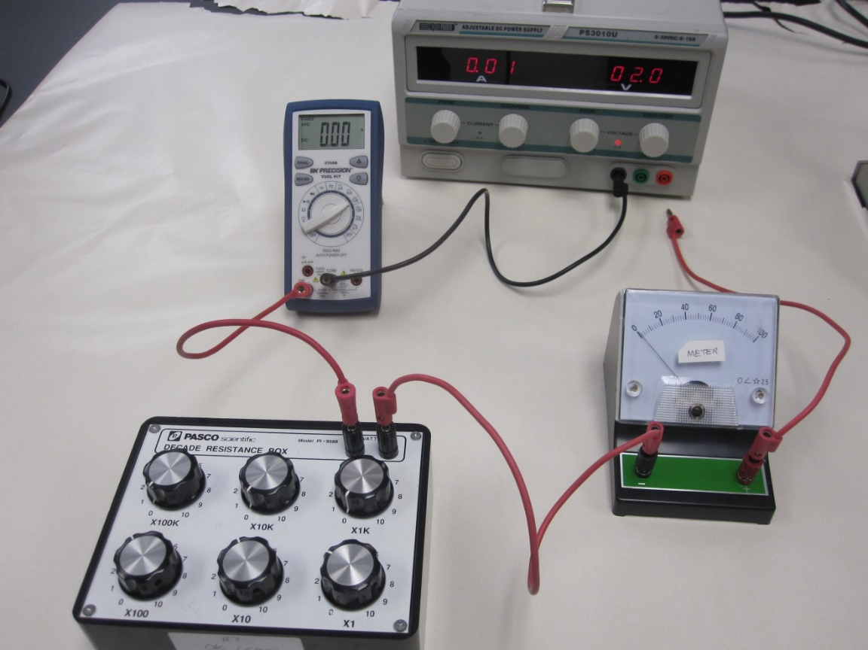
- Have your construction checked by the instructor.
- Slowly and carefully increase “FINE” voltage and/or lower the resistance until the meter reaches full scale.
- Measure the full-scale current, by switching the DMM to read in mA. Record this full-scale current below.
Full scale current of the meter, I_{C} =
- Disconnect the circuit.
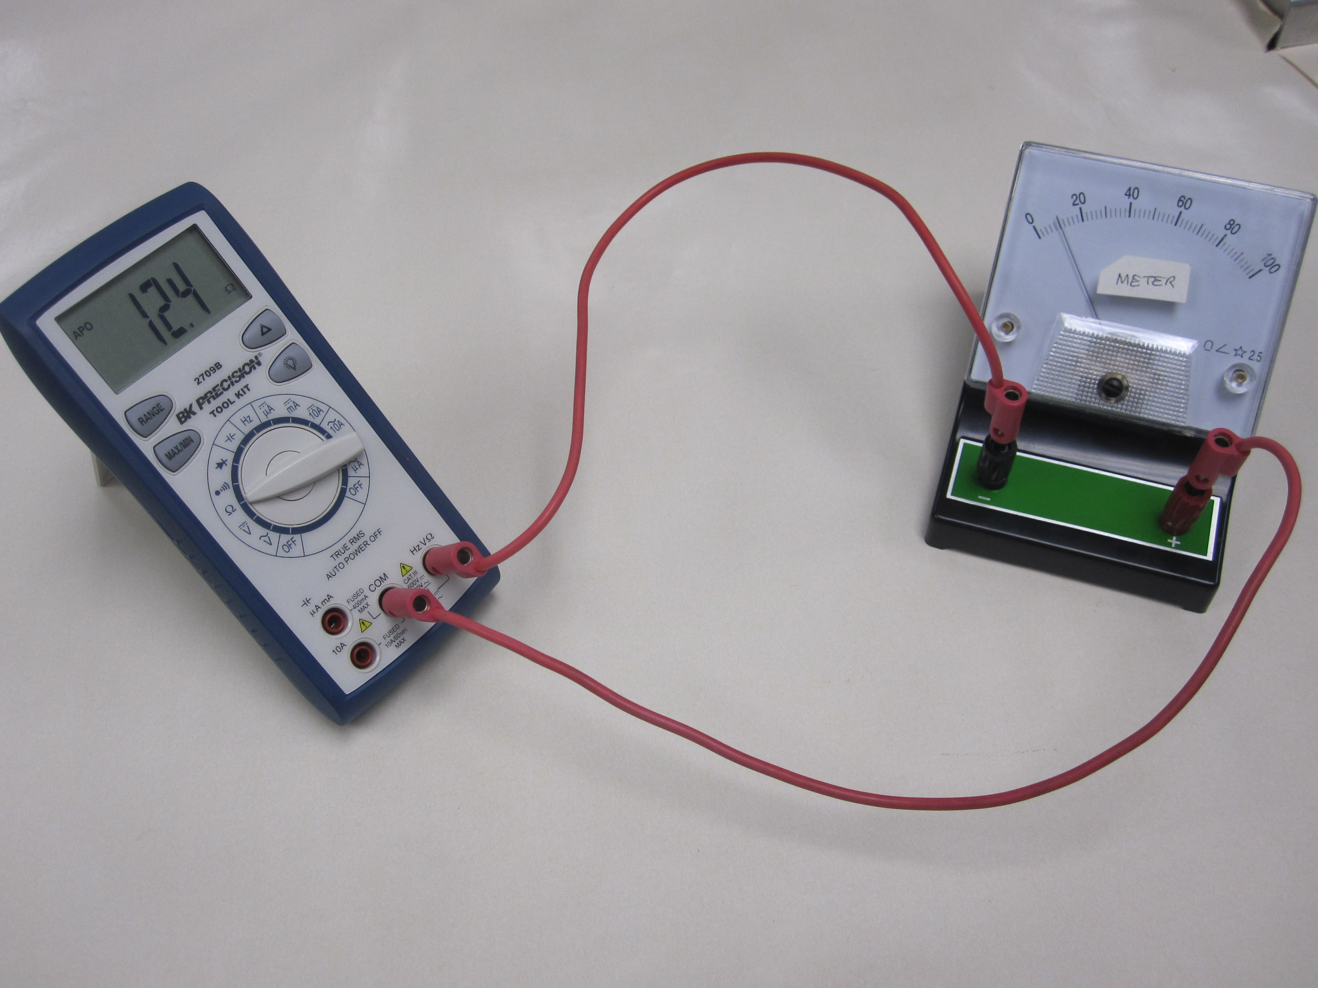
- Measure the internal coil resistance of the meter
by connecting it directly to the DMM, as shown.
Resistance of the meter, R_{C} =
B) Construction of a voltmeter:
1. A resistance, R_{S} is placed in series with the meter to convert it to a voltmeter as shown below.
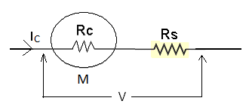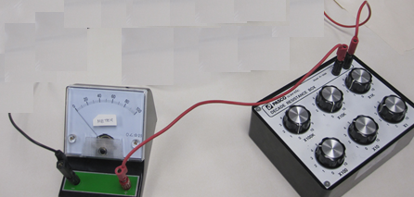
$$V=I_{C}(R_{C}+R_{S})$$
2. Calculate the series resistance, R_{S} for a 10-volt voltmeter. Use I_{C} and R_{C} values you measured from part (A).
R_{S} = _____________
3. To construct the voltmeter; connect the resistance, R_{S} in series with the meter. Use the decade box for R_{S}.
4. While the RED plug is unplugged, set up the following circuit and get the construction checked by the instructor, who will plug in the RED plug.
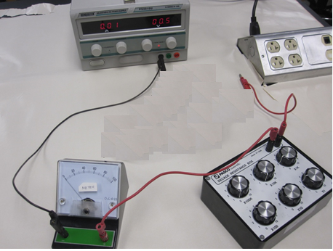
5. The constructed voltmeter should read full scale for 10-volt, if not adjust R_{S}.
6. Change the voltage and complete the following table. R_{S} = _____________
Voltmeter reading ( V ) | Constructed voltmeter reading (meter scale)
10
9
8
7
6
5
4
3
2
1
C) Construction of an ammeter
1. A resistance (R_{P}) is placed in parallel with the meter to convert it to an ammeter as shown below.
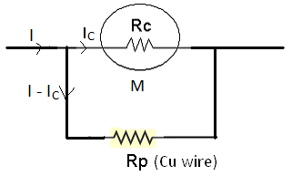
$$I_{C}R_{C}=(I-I_{C})R_{p}$$
2. Calculate the parallel resistance, R_{P} for a 20-mA ammeter. R_{p} = _____________
3. Measure the diameter of the nichrome wire = __________________
4. Calculate the length (L) in cm of nichrome wire required to obtain R_{P}.
L = _____________
Resistivity of nichrome = 114 x 10⁻⁶ Ω.cm.
5. Cut a piece of nichrome wire of length (L+2) cm.
6. Construct the ammeter by connecting the nichrome wire in parallel with meter, as shown below, using the connector box. The extra 2-cm will be wasted in the connections. 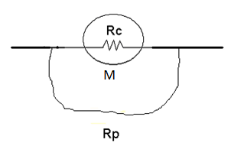 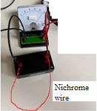
6. While the RED plug is unplugged, set up the following circuit to measure currents and get the construction checked by the instructor. Decade box (60-Ω), DMM set to mA.
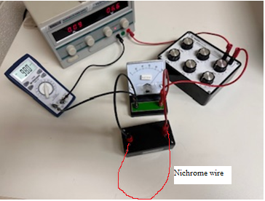
- Keep the voltage to 2.0 V on the power supply and change the resistance from the resistance box. The constructed ammeter should deflect full scale for 20 mA. If not call the instructor who will adjust the length of Nichrome wire to get full scale deflection.
- Change the current by changing the resistance and complete the table below. New length of the wire =_________

ammeter reading (mA) | 20 | 18 | 16 | 14 | 12 | 10 | 8 | 6 | 4 | 2
Constructed ammeter reading (meter scale)
9. Conclusion on a separate last page, make sure to answer the purpose of the lab, include your experimental data, and reflect.

