PHYS 212L Magnetic Force
Name:_____________________________
Partner(s):_______________________________________________________________

- Introduction: The purpose of this lab is to explore the forces on a permanent magnetic dipole moment μ caused by various external magnetic fields.

- Pre-lab:
- A current carrying wire is in a magnetic field B, show the direction of the current, the magnetic field and use the right-hand rule to find the direction of magnetic force using for the situation shown below.

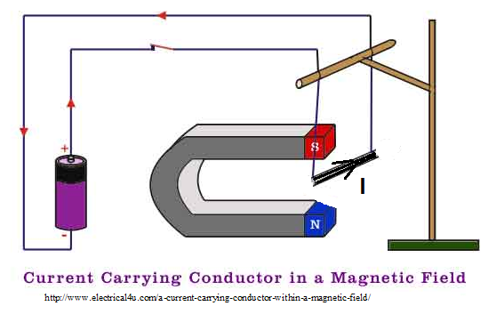
Fig.1

- The magnetic force is given by $\vec{F}=I\vec{l} ×\vec{B}$
In the figure below, a current flows through the loop of wire in a magnetic field represented in the figure below.
- What is the direction of the current in the loop?
- Draw the magnetic force for both portions of the wire?

$\vec{B}$
I

Fig.2

- In the figures below, if the magnetic is uniform and the loop is symmetric, torques will be created if the wire carries a current I
- Draw the forces on each segment of the wire for both figures
- What will be the equation of the torque in the loop?

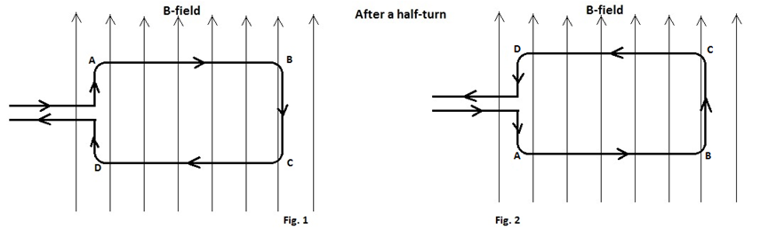
Fig. 3

- Experiment

Overview: There are three main objectives to the experiments with MFl-A:
- To realize that a net magnetic force on a magnetic dipole exist only when it is in the presence of a magnetic field gradient, that is, a spatially varying field.
- To determine the magnitude of the magnetic moment µ of the dipole by measuring the magnetic force in the presence of a field gradient dB_{z}/dz.
- To measure the axial magnetic field gradient of a current carrying circular loop of wire.

Material: Power supply, 3 wires, and Magnetic Force (MF1-A) instrument.

3.1 Magnetic forces measurements
The MF1A instrument is designed to explore the forces on a permanent magnetic dipole moment μ caused by various external magnetic fields.
Theory:
The expression for the axial magnetic field of an N turns loop is
$$B_{z =}\frac{μ_{0 }I N}{2} \frac{R^{2}}{{[z^{2}+R^{2}]}^{\frac{3}{2}}}$$
N is the number of turns/loop (N=168turns), R is the mean radius and R=0.07m
Differentiation with respect to z gives
$$\frac{{dB}_{z}}{dz}=\frac{3 I N}{2} \frac{R^{2}z}{{[z^{2}+R^{2}]}^{\frac{5}{2}}}$$

The field gradient at the midpoint for two coils of N turns/coil in the Helmholtz configuration (z = R/2) is
$$\frac{{dB}_{z}}{dz}=0.859μ_{0}N\frac{I}{R^{2}} (\frac{Tesla}{meter})$$
For the MF1-A Coils (two coils) : N=168, and R=0.07 m:
$$\frac{{dB}_{z}}{dz}=0.037 I$$
For 3 amperes:
$$\frac{{dB}_{z}}{dz}=0.111 T/m$$
These straightforward calculations will help cement the impressions that the (MF1-A) produces a uniform field with the same directed currents, and a constant field gradient over the same central region with opposite directed currents in its coils. These equations will be needed in the experiments you will perform.
The axial force is given by: ${ F}_{z}=μ\frac{{dB}_{z}}{dz}$ and the torque $τ=μ×F_{z}$

  - Instrument

Magnetic Force" MF1-A consists of a pair of coils mounted in the so called "Helmholtz" configuration and a small neodymium-iron-boron disk permanently magnetized along its cylindrical axis. This disk is the model system for an ideal magnetic dipole moment. It is mounted in a Delrin plastic gimbal so it is free to rotate about the gimbal axis, and is suspended by a long precision nonmagnetic spring, as shown in the diagram. The opposite end of the spring connects to a brass rod which is held in place on the top of the transparent plastic tower by a thumb screw in the Delrin cap. The spring conforms to Hook's law, within the experimental error of the apparatus. However, it must be calibrated for the measurements, since the spring constant may change over time due to mishandling and permanent elastic deformation.

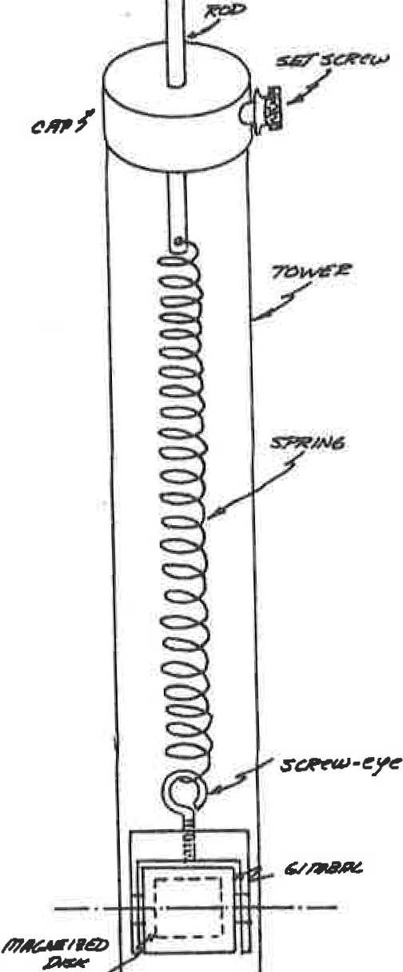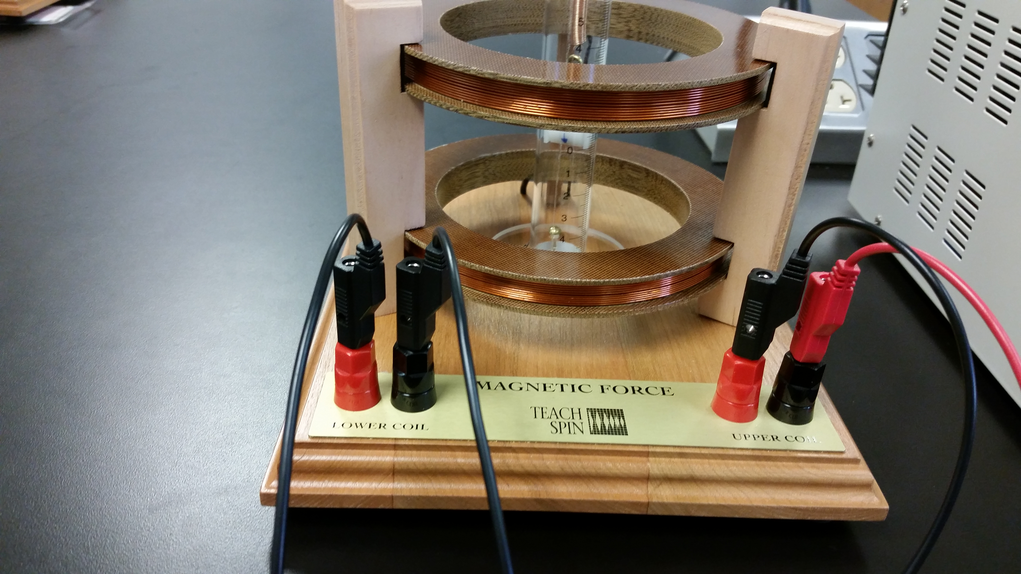
Fig. 5

MFl-A SPECIFICATIONS:
Two coils
  - 168 turns/coil, #20 fonnvar insulated copper wire Mean radius 7.0 cm
- Coil separation 7.0 cm (Helmholtz conditions)
- Maximum current 3A (for longtime periods)
- Coil Resistance 2.80Ω/coil
- Coils are surge protected against back emf
- Positive current flowing into the red binding post will produce a magnetic field in the upward vertical direction along the coils axis's. This is true for both the upper and lower coils. ·

3.3 Procedure
The instrument requires an external variable power supply capable of passing 3 amperes through a resistance of 5.6 ohm, or about 17 volts, and 3 wires. You should not exceed 3 amperes for a significant time, since the coils will overheat and could cause damage to you and the instrument.
Remember the magnetic field only depends on the current, for a given set of windings. The ball bearings have a mass close to 1.0 g.
Note: Do not operate the coils in parallel. The current will not necessarily divide equally between the two coils and thus give rise to unpredictable field.
- Calibration of the spring constant k: ( No current is applied)

Use the five l.0 g steel ball bearings as weights, stick the ball to the Delrin plastic gimbal. Make sure that the bottom of the gimbal is at zero scale.
The spring constant should be determined by measuring the spring elongation for 1, 2, 3, 4, and 5 steel ball bearings. This should come out to be about 1.04 N/m. The magnet should be midway between the 2 coils. Be careful of the spring, it can be permanently damaged by over stretching it while you are handling it. The spring constant can be determined from the slope of the graph, and Hooke’s law F=kz.
Measure the elongation of the spring z when varying the mass of the steel ball from 1.0g to 5.0g and fill the table below.

Number of balls bearings | Mass (g) | Force=mg | Spring elongation z(cm)
0 | 0
1 | 1.0
2 | 2.0
3 | 3.0
4 | 4.0
5 | 5.0

Plot F versus x and determine the spring constant. K=
The graph needs to be added to your report.

- Application of a current: Connect the coils to a d.c. power supply capable of producing at least 3A at 17V.
(The + of the power supply should be connected to the black connection of the upper coil, the red connection of the upper coil should be connected to the red connection of the lower coil, and the black connection of the lower coil should be connected to the – of the power supply). The coils are connected in series so that the current will flow in the same direction in the upper and lower windings. The dipole μ in the gimbal is placed at the center of the two coils and the current turned on. No spring deflection should be observed.
Adjust the brass rod in such a way that the magnetic dipole hangs in the central region of the two coils, near zero on the scale (the gimbal between the two coils). For this configuration the current produces a magnetic field gradient, when the current is turned on.

  - Turn on full current (3 A). What happened?

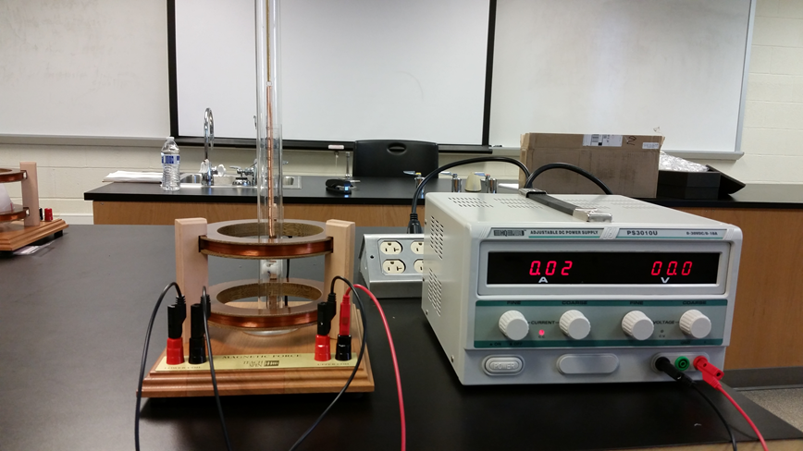
Fig. 6

Reverse the current through both coil (in the power supply).

  - What happened? Explain all you observed.

For this current configuration the currents produce a field gradient in the central region and zero field at the exact center. The dipole is placed at the center, the current turned on and the spring is stretched (or compressed) as the dipole experiences an axial force µ$\frac{{dB}_{z}}{dz}$.
Now you should be ready to measure the magnetic moment mounted in the gimbal. The coil remains wired to produce a field gradient in the central region where I is in amperes
$$\frac{{dB}_{z}}{dz}=0.371 I$$
The dipole is placed at the center of the coils and the current turned on. The spring elongation is measured as a function of current. Slowly increase the current and record the values of the elongation z when changing the current from 0A to 3 A and calculate the field gradient $\frac{{dB}_{z}}{dz}$.

I (A) | Elongation z (cm) | $$\frac{{dB}_{z}}{dz}=0.371 I$$
0
0.5
1.0
1.5
2.0
2.5
3.0

  - Plot the spring elongation versus I and include it to your lab report.
  - The measured spring constant is K=0.0104N/cm. Using a single point form your data, calculate the dipole moment using the equation:
$μ=\frac{F}{\frac{{dB}_{z}}{dz}}$ , $F =kz$

$$μ=$$

C. Connect the two-coil system in series in such a way that the current flows in the opposite direction in each coil. To do this you need reverse the leads to the power supply. Again, place the magnetic dipole at the center and turn on the supply to 3A through the coils.

Again, change the current from 0 to 3A, and record the elongation z, and calculate the field gradient$\frac{ {dB}_{z}}{dz}$ .
I (A) | Elongation z (cm) | $$\frac{{dB}_{z}}{dz}=0.371 I$$
0
0.5
1.0
1.5
2.0
2.5
3.0

  - Plot the spring elongation versus I and include the graph to your lab report.
  - The measured spring constant is K=0.0104N/cm. Using a single point form your data, calculate the dipole moment using the equation: used in part 2.

$$μ=$$

  - With 3A flowing through the coils, lower the dipole to the bottom of the tower and slowly raise it up (by raising up the brass rod) through the central region to above the top coil. Now lower the dipole down to the bottom of the tower. Repeat this procedure several times, carefully watching and recording qualitatively what happens. Give a brief but clear explanation of what you observed. Hint: this "simple" experiment demonstrates both magnetic torque and magnetic force.

- Conclusion:

