PHYS 212L [Capacitor Lab](http://www.youtube.com/watch?v=AamT_L2M-N0)

Name:_________________________________

**A. Purpose: To investigate various combinations of capacitors.**

Apparatus: Three capacitors, digital multimeter, and banana plug wires.

Theory:  
  
When two or more capacitors are connected in series the equivalent capacitance, CS is given by;

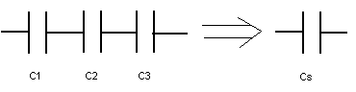



When two or more capacitors are connected in parallel the equivalent capacitance, CP is given by;

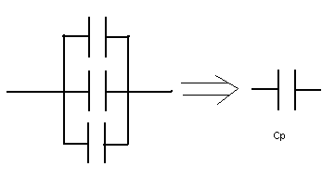



Procedure:  
1. Measure the values of the three capacitors using the digital multimeter (DMM) and record them in the data table.

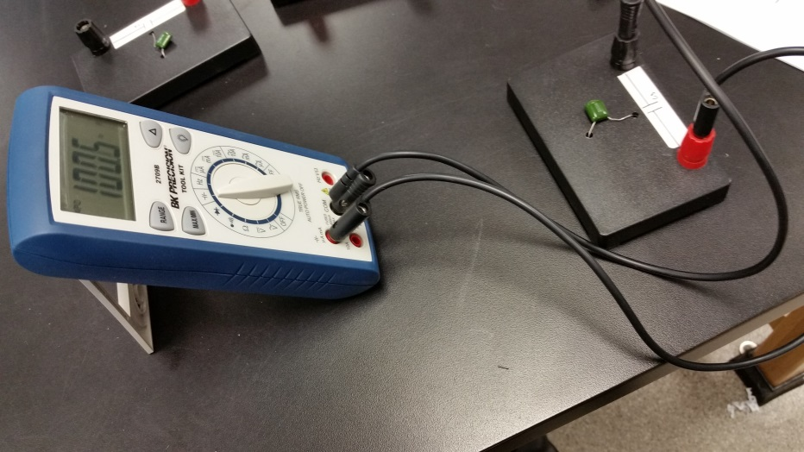

2. Connect the three capacitors in various combinations and sketch the combination diagram. Also, measure and calculate the equivalent capacitances.   
3. After completing the data table, identify the highest capacitance and the lowest capacitance in the data table.

DATA: Measured values: C1= _______       C2 = _______    C3 =__________

|  |  |  |
| --- | --- | --- |
| Capacitor Combination Diagram | Capacitance Values | |
| Measured | Calculated |
| All three in series |  |  |
| All three in parallel |  |  |
|  |  |  |
|  |  |  |
|  |  |  |
|  |  |  |
|  |  |  |
|  |  |  |

Identify the highest capacitance and the lowest capacitance in the data table, above.

1. **Purpose: Investigate the discharge characteristics of a capacitor.**

Apparatus: PC with Pasco 750 interface, capacitor, power supply, alligator clips (2), voltage sensor, decade resistance box, light bulb, knife-switch, and connecting wires (4).

Theory: The capacitance (C) of a capacitor is given by, where Q is the charge stored and V is the potential difference.



The SI unit for capacitance is the Farad (F). Farad = Coulomb/Volt. Time constant, RC is used to indicate how fast the charge is discharged. The unit of RC is second. Time constant is the time required to discharge a capacitor of capacitance, C through a resistor, R to 36.8% of the initial charge.   
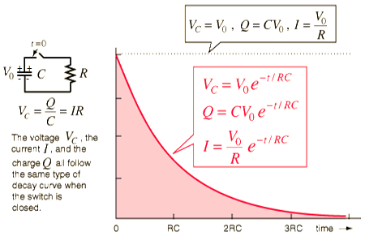

The charge stored is equal to the product of current and time, which can also be determined by finding the area under the Current versus Time graph.

<http://hyperphysics.phy-astr.gsu.edu/hbase/electric/capdis.html>

Procedure:

1. Plug in the power supply, set the voltage to 4 volts, which is *V*in the data table.
2. Keeping the black wire un-plugged from the power supply, set up the following circuit, which will be used to charge and discharge the capacitor. Make sure that the + end of the power supply is connected with the + end of the capacitor and + end of the current sensor. Set the resistance box to 5 Ω. Have the circuit checked by instructor.

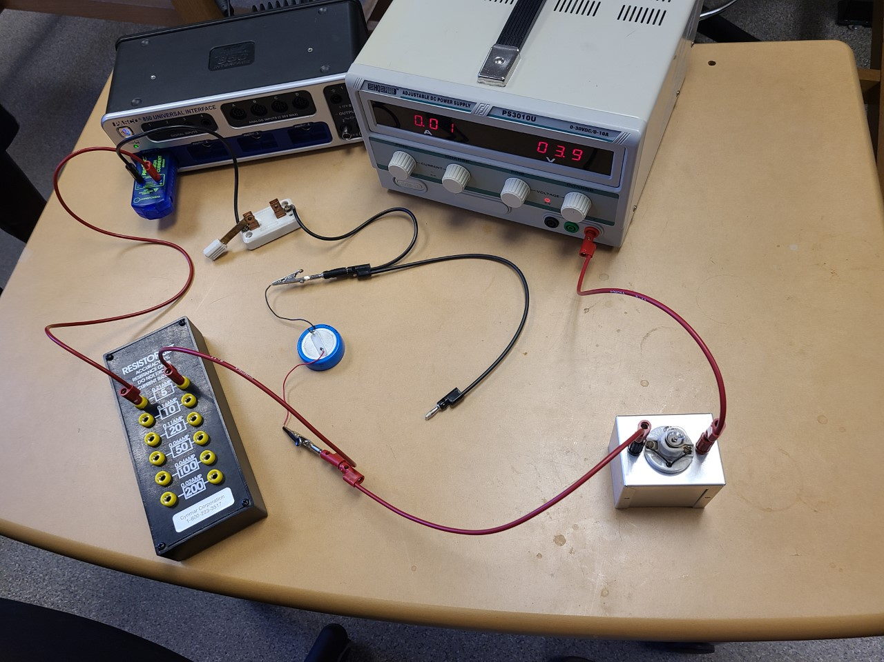

1. While the knife-switch is open, plug in the black banana plug to fully charge the capacitor, for about 3 minutes, until the bulb goes off.
2. Setting up the Interface:   
   a. Make sure that the power for the interface is turned on.  
   b. Plug in the current sensor to analog input A on the interface.  
   c. Open **PASCO Capstone** software from the desktop.   
   d. Click **Hardware Setup** under Tools on the left, click on the interface input where the sensor is connected and select **Current Sensor**. Click **Hardware Setup** again to close it.   
   e. Double-Click **Graph** under Displays on the right, click **Select Measurement**, and select **Current (A).**    
   f. Click **Record,** un-plug the black banana plug, and close the knife-switch to discharge the capacitor through the 5-ohm resistance.
3. Continue collecting data until the capacitor is completely discharged, as shown below, for about a minute for R = 5 ohm (this time will be higher for higher R), and stop the data collection.

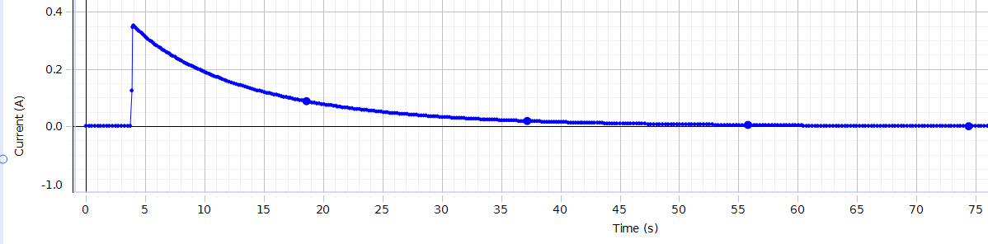

1. Maximize the data by clicking **Scale axes to show all data** tool (1st one on the top-left).
2. Find the area under the curve, which is the total charge (*Q*), and **display area under active data** tool (6th from left).

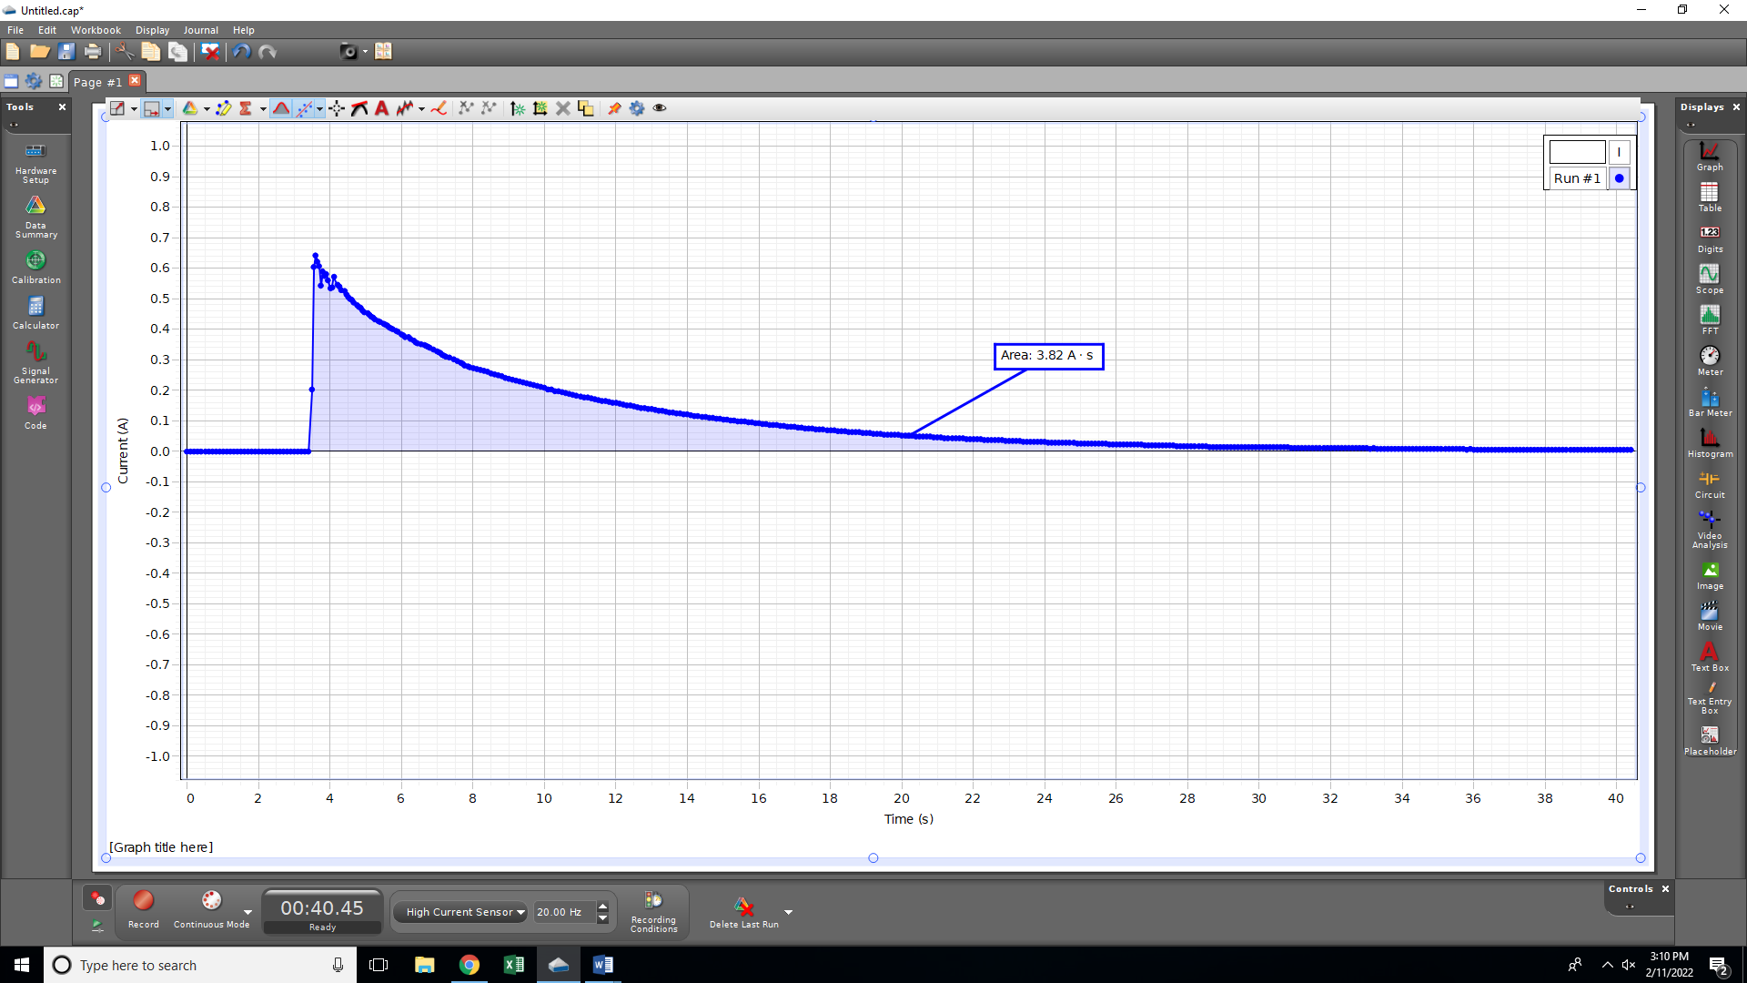

1. Highlight the discharging portion of the graph by using the **Highlight range of points in active data** tool(4th from left), fit it with a natural exponent function, and obtain the time constant from the fit.

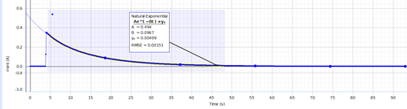

1. Open the knife switch, change the R to 10 -ohm and plug the black banana plug to the power supply, wait until the bulb goes off, and repeat the step f.
2. Repeat the measurements for other R values and complete the data table.

DATA: Include units for measured/calculated values inside ( ).

|  |  |  |  |  |  |  |
| --- | --- | --- | --- | --- | --- | --- |
| Res.  Box  (Ω) | *V* (volt) | Charge *Q* ( ) | Capacitance  ( ) | Time Constant* using R & C values ( ) | Constant *B* from fit ( ) | Time Constant from fit** ( ) |
| 5 | 4 |  |  |  |  |  |
| 10 | 4 |  |  |  |  |  |
| 20 | 4 |  |  |  |  |  |
| 50 | 4 |  |  |  |  |  |

** Time constant = *RC*.

***In terms of the exponent coefficient ‘B’ of the Natural Exponent Fit, the time constant, *RC* is given by: 

1. **Write an overall Conclusion:**