**Chapter 26**

**11.** (II) A battery with an emf of 12.0 V shows a terminal voltage of 11.8 V when operating in a circuit with two lightbulbs, each rated at 4.0 W (at 12.0 V), which are connected in parallel. What is the battery’s internal resistance?

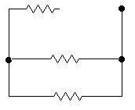11. The resistance of each bulb can be found from its power rating.



Find the equivalent resistance of the two bulbs in parallel.



The terminal voltage is the voltage across this equivalent resistance. Use that to find the current drawn from the battery.



Finally, use the terminal voltage and the current to find the internal resistance, as in Eq. 26-1.



**18.** (II) (*a*) Determine the equivalent resistance of the “ladder” of equal resistors shown in Fig. 26–40. In other words, what resistance would an ohmmeter read if connected between points A and B? (*b*) What is the current through each of the three resistors on the left if a 50.0-V battery is connected between points A and B?



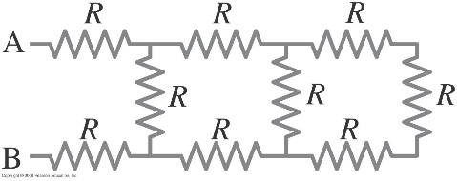

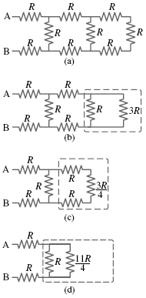18. (*a*) The three resistors on the far right are in series, so their equivalent

resistance is 3*R*. That combination is in parallel with the next resistor to the left, as shown in the dashed box in the second figure. The equivalent resistance of the dashed box is found as follows.



This equivalent resistance of  is in series with the next two resistors, as shown in the dashed box in the third figure (on the next page). The equivalent resistance of that dashed box is  This  is in parallel with the next resistor to the left, as shown in the fourth figure. The equivalent resistance of that dashed box is found as follows.

 

This is in series with the last two resistors, the ones connected directly to A and B. The final equivalent resistance is given below.



(*b*) The current flowing from the battery is found from Ohm’s law.



This is the current in the top and bottom resistors. There will be less current in the next resistor because the current splits, with some current passing through the resistor in question, and the rest of the current passing through the equivalent resistance of , as shown in the last figure. The voltage across *R* and across  must be the same, since they are in parallel. Use this to find the desired current.



**28.** (II) Determine the terminal voltage of each battery in Fig. 26–46.

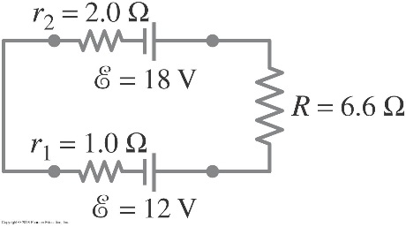

28. Apply Kirchhoff’s loop rule to the circuit starting at the upper left corner of the circuit diagram, in order to calculate the current. Assume that the current is flowing clockwise.



The terminal voltage for each battery is found by summing the potential differences across the internal resistance and EMF from left to right. Note that for the 12 V battery, there is a voltage gain going across the internal resistance from left to right.

Vterminal=-I(1.0) + 12V=(-0.625A)(1.0 Ω)+12V=11.375V



**32.** (II) Calculate the currents in each resistor of Fig. 26–50.

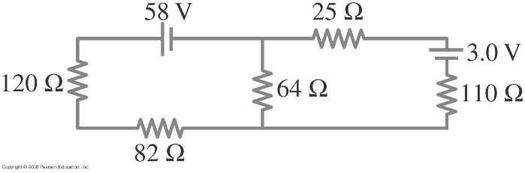

There are three currents involved, and so there must be three independent equations to determine those three currents. One comes from Kirchhoff’s junction rule applied to the junction of the three branches at the top center of the circuit.



Another equation comes from Kirchhoff’s loop rule applied to the left loop, starting at the negative terminal of the battery and progressing counterclockwise.



The final equation comes from Kirchhoff’s loop rule applied to the right loop, starting at the negative terminal of the battery and progressing counterclockwise.



Substitute  into the left loop equation, so that there are two equations with two unknowns.



Solve the right loop equation for  and substitute into the left loop equation, resulting in an equation with only one unknown, which can be solved.



The current in each resistor is as follows:



**50.** (III) Determine the time constant for charging the capacitor in the circuit of Fig. 26–61. [*Hint*: Use Kirchhoff’s rules.] (*b*) What is the maximum charge on the capacitor?

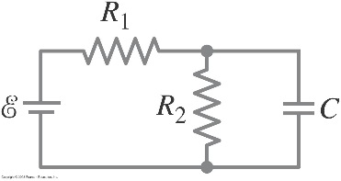

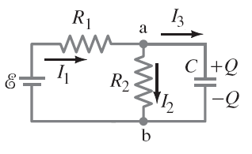50. (*a*) With the currents and junctions labeled as in the diagram, we use point a for the junction rule and the right and left loops for the loop rule. We set current *I*3 equal to the derivative of the charge on the capacitor and combine the equations to obtain a single differential equation in terms of the capacitor charge. Solving this equation yields the charging time constant.



We use Eq. [1] to eliminate *I*1 in Eq. [2]. Then we use Eq. [3] to eliminate *I*2 from Eq. [2].



We set *I*3 as the derivative of the charge on the capacitor and solve the differential equation by separation of variables.



From the exponential term we obtain the time constant, 

(*b*) We obtain the maximum charge on the capacitor by taking the limit as time goes to infinity.



**51.** (III) Two resistors and two uncharged capacitors are arranged as shown in Fig. 26–62. Then a potential difference of 24 V is applied across the combination as shown. (*a*) What is the potential at point a with switch S open? (Let at the negative terminal of the source.) (*b*) What is the potential at point b with the switch open? (*c*) When the switch is closed, what is the final potential of point b? (*d*) How much charge flows through the switch S after it is closed?



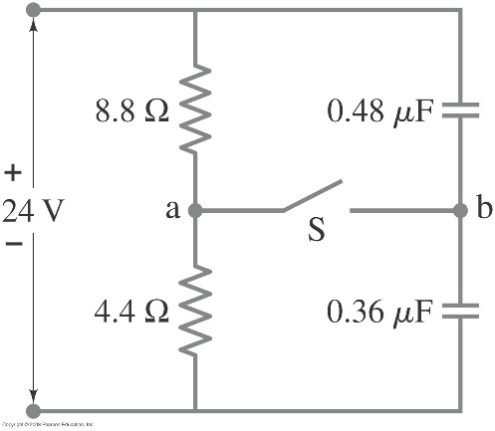

51. (*a*) With the switch open, the resistors are in series with each other, and so have the same current.

Apply the loop rule clockwise around the left loop, starting at the negative terminal of the source, to find the current.



The voltage at point a is the voltage across the -resistor.



(*b*) With the switch open, the capacitors are in series with each other. Find the equivalent

capacitance. The charge stored on the equivalent capacitance is the same value as the charge stored on each capacitor in series.



The voltage at point b is the voltage across the -capacitor.



(*c*) The switch is now closed. After equilibrium has been reached a long time, there is no current

flowing in the capacitors, and so the resistors are again in series, and the voltage of point a must be 8.0 V. Point b is connected by a conductor to point a, and so point b must be at the same potential as point a, . This also means that the voltage across  is 8.0 V, and the voltage across  is 16 V.

(*d*) Find the charge on each of the capacitors, which are no longer in series.



When the switch was open, point b had a net charge of 0, because the charge on the negative plate of  had the same magnitude as the charge on the positive plate of . With the switch closed, these charges are not equal. The net charge at point b is the sum of the charge on the negative plate of  and the charge on the positive plate of .



Thus  of charge has passed through the switch, from right to left.