1. (I) A uniform electric field of magnitude 5.8 $×{10}^{2}N/C$ passes through a circle of radius   
   13 cm. What is the electric flux through the circle when its face is (*a*) perpendicular to the field lines, (*b*) at 45° to the field lines, and (*c*) parallel to the field lines?

**6.** (I) Figure 22–26 shows five closed surfaces that surround various charges in a plane, as indicated. Determine the electric flux through each surface,  and  The surfaces are flat “pillbox” surfaces that extend only slightly above and below the plane in which the charges lie.

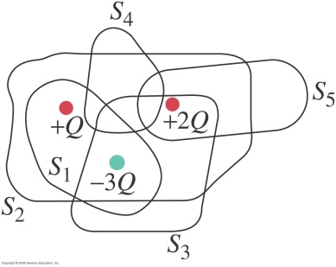

**24.** (II) Two large, flat metal plates are separated by a distance that is very small compared to their height and width. The conductors are given equal but opposite uniform surface charge densities $±σ$ Ignore edge effects and use Gauss’s law to show (*a*) that for points far from the edges, the electric field between the plates is E= $σ/{ϵ_{0}}$ and (*b*) that outside the plates on either side the field is zero. (*c*) How would your results be altered if the two plates were nonconductors? (See Fig. 22–30).

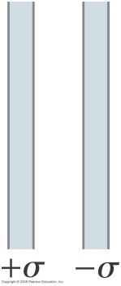

**27.** (II) Two thin concentric spherical shells of radii  and   contain uniform surface charge densities $σ_{1}$ and $σ_{2}$ respectively (see Fig. 22–31). Determine the electric field for (*a*)  (*b*)  and (*c*)  (*d*) Under what conditions will  for  (*e*) Under what conditions will  for  Neglect the thickness of the shells.

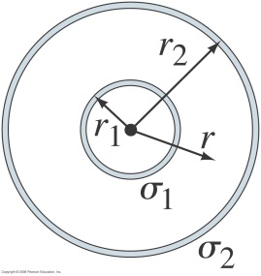

**35.** (II) A thin cylindrical shell of radius  is surrounded by a second concentric cylindrical shell of radius  (Fig. 22–35). The inner shell has a total charge $+Q$ and the outer shell $-Q.$ Assuming the length $l$ of the shells is much greater than  or  determine the electric field as a function of *R* (the perpendicular distance from the common axis of the cylinders) for (*a*)  (*b*)  and (*c*)  (*d*) What is the kinetic energy of an electron if it moves between (and concentric with) the shells in a circular orbit of radius  Neglect thickness of shells.

