PHYS211 Speed of Sound in Air
Name: __________________ Partner(s): ______________________
Purpose: Determine the speed of sound in air using different methods.
https://www.youtube.com/watch?app=desktop&v=GkNJvZINSEY

A. Temperature Method
Apparatus: PC with interface and temperature sensor.
Theory: Speed of sound in air (in m/s) at temperature T (in Kelvin) is given by;
where γ = 1.40 (ratio of specific heats for air),
m = 4.8 x 10⁻²⁶ kg (average molecular mass of air), and
k = 1.38 x 10⁻²³ J/K (Boltzmann constant).
Procedure
Measure the room temperature using a temperature sensor, interface, and PC and calculate the speed of sound.
a. Make sure that the power for the interface is turned on.
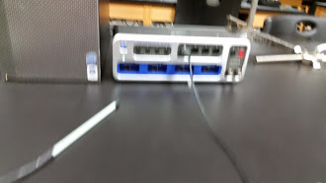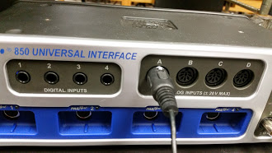
b. Plug in the temperature sensor to analog input A, white arrow on top.
c. Open PASCO Capstone software from the desktop.
d. Click Hardware Setup under Tools on the left, click on the interface input where the sensor is connected and select Temperature Sensor. Click Hardware Setup again to close it.
e. Double-Click Digits under Displays on the right, click Select Measurement, and select Temperature.
f. Click Record.
DATA:
Room temperature, t = ___________^{ᵒ}C = _________K.
Speed of sound (using temperature) = V = ____________
Q: Calculate the average molecular mass of air (dry air) using the three most abundant gases found in the Earth’s lower atmosphere (Ni, O, Ar). http://www.physicalgeography.net/fundamentals/7a.html
B. Air-Column Resonance Method
Watch the video below
https://www.youtube.com/watch?app=desktop&v=d7W2niNqHWg
Apparatus: Resonance tube apparatus, audio signal generator, speaker, stand w/clamp, and water.
Theory: In wind instruments the wind (air) is made to resonate. Resonance makes the sound audible.
Procedure: In this investigation a small speaker, connected to an audio signal generator, will generate sound of required frequencies.
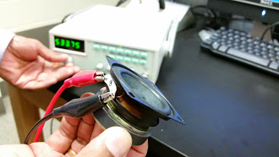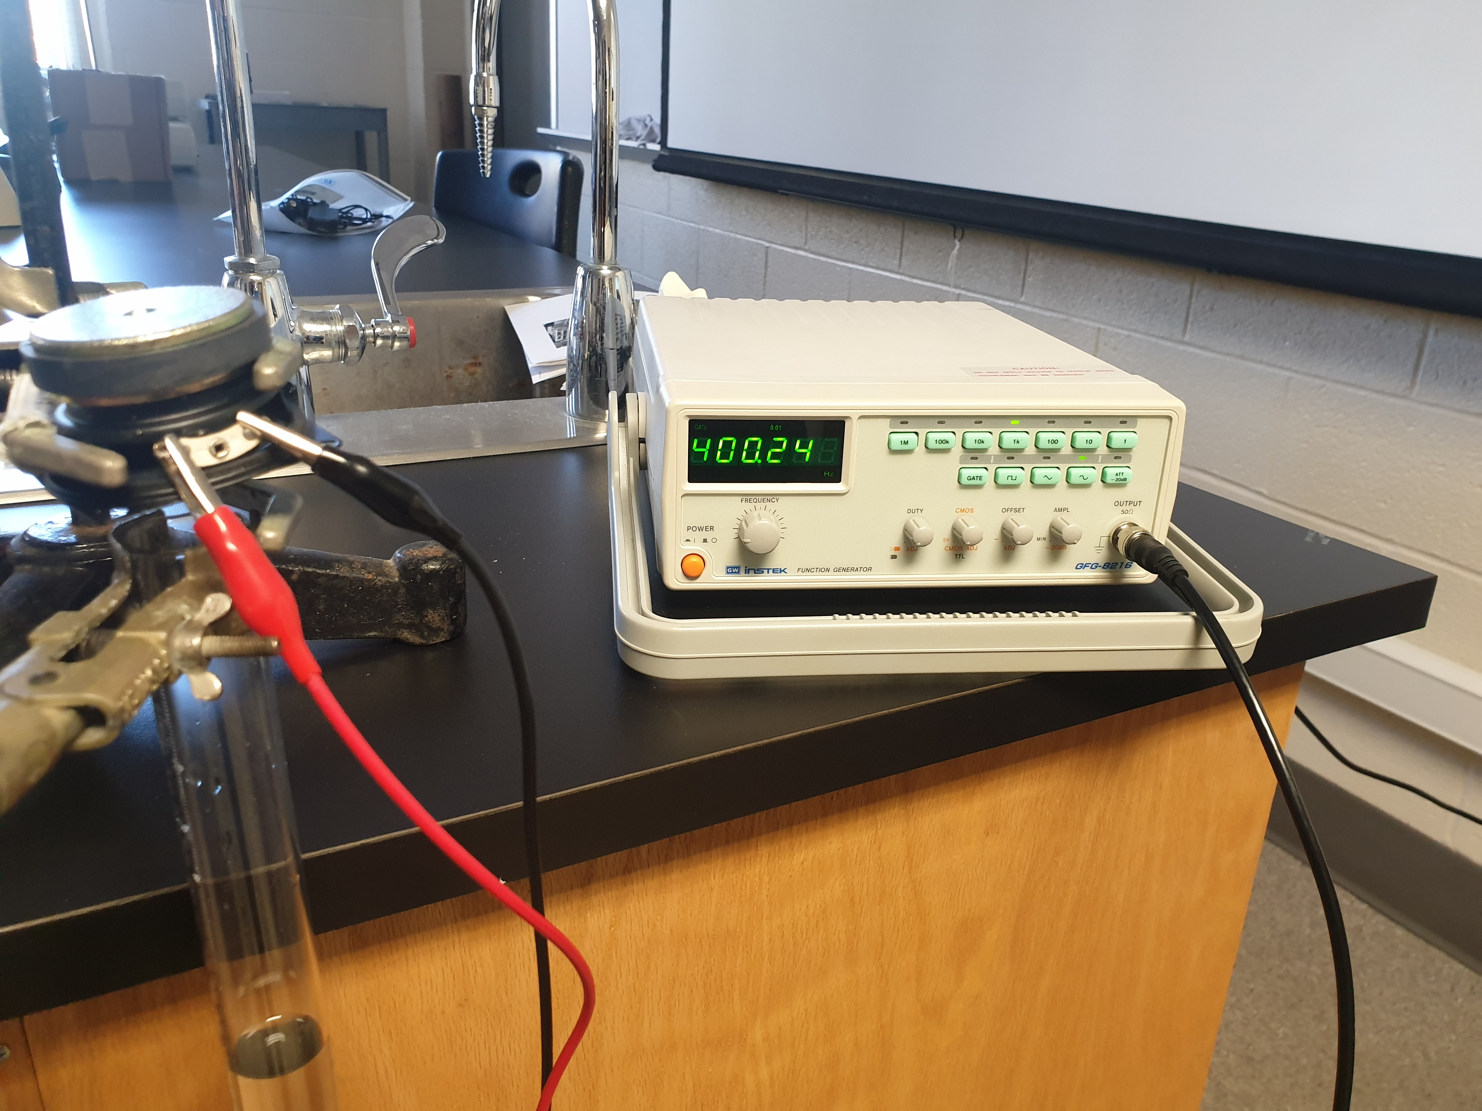

The speaker is held above the open end of the resonance tube, which has water. The water level can be changed by lowering/raising the reservoir can.

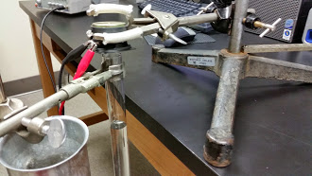
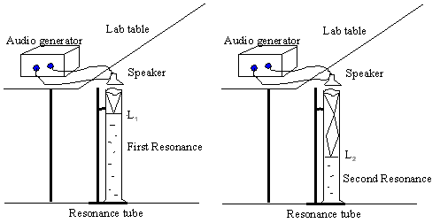
Lower the water level by moving the water can; keep your ear next to the speaker and listen carefully. At the first resonance, L₁ the sound will be louder. If you keep on lowering you will hear the loud sound again at the second resonance, L₂. The wavelength, λ is given by: λ = 2 (L₂ - L₁). The speed of sound in air, V is given by: V = λf; f = frequency.
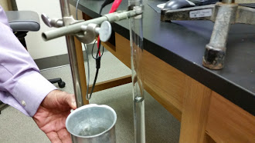

DATA
Dial  Frequency  (Hz) | First  Resonance  Point, L₁ | Second Resonance Point, L₂ | Change in Resonance Points,  L₂-L₁ | Wavelength, λ | Speed of sound, V
400 | - | - | - | - | -
500 | - | - | - | - | -
600 | - | - | - | - | -
Average Speed of Sound
C. Echo Method
Apparatus: Sound sensor, interface, PC, long cardboard tube, and meter stick.

Theory:
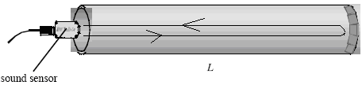

In this echo method, a sound pulse is made to travel along the tube, and the initial pulse and the reflected pulse are detected with a sound sensor.

If the length of the tube is L, then the round trip distance of travel is 2L. If the travel time is t, then the speed of sound, v is given by;

Procedure:

- Turn on the Pasco 850 interface, and connect the sound sensor to analog input A.

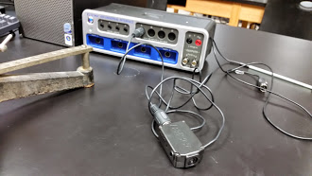

2. Open PASCO Capstone software from the desktop.
3. Click Hardware Setup under Tools on the left, click on the interface input where the sensor is connected, and select Sound Sensor. Click Hardware Setup again to close it.
4. Click Recording Conditions, in the bottom-panel, and do the following.
a. Start Condition:
Condition type = Measurement Based
Data Source = Sound Intensity
Condition = Is above
Value = 1
b. Stop Condition:
Condition type = Time Based
Record time = 0.5s
c. Click, OK.
5. Double-Click Scope under Displays on the right, click Select Measurement on the Y-axis, and choose Sound Intensity.
6. Place the cardboard tube on the laboratory table and hold the sound sensor close to the open end.

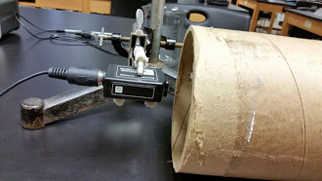

7. Click Record, and snap your fingers at the open end of the tube as shown below.
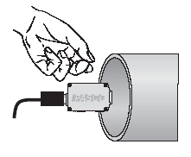
8. If the pulse is not captured, repeat procedure 7. If the pulse is visible, but not the echo, drag the x-axis scale numbers until the pulse and echo are visible as shown below.
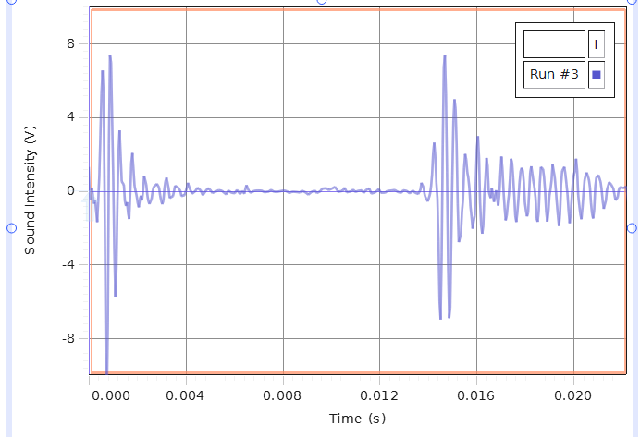

9. Click the Show Coordinates button (on top), right-click the coordinate, and select Tool Properties, and change the significant figure to 4.
10. Use the Show Coordinates tool to find the time for initial pulse, time for echo, and travel time and complete the data table below.

11. Repeat the measurements.
Length of tube  (m) | Round trip travel Distance (m) | Time for initial pulse (s) | Time for echo (s) | Travel Time  (s) | Speed of sound  (m/s)

12. Write an overall conclusion.

