**Chapter 7:**

**16.** (I) What is the dot product of  and 

**19.** (I) Show that **A $∙$**($-$**B)**= $-$ (**A $∙$** **B**)

**46.** (II) Assume that a force acting on an object is given by  where the constants *a*=3.0N/m and *b*=4.0N/m. Determine the work done on the object by this force as it moves in a straight line from the origin to 

**Chapter 8:**

**20.** (II) A roller-coaster car shown in Fig. 8–32 is pulled up to point 1 where it is released from rest. Assuming no friction, calculate the speed at points 2, 3, and 4.

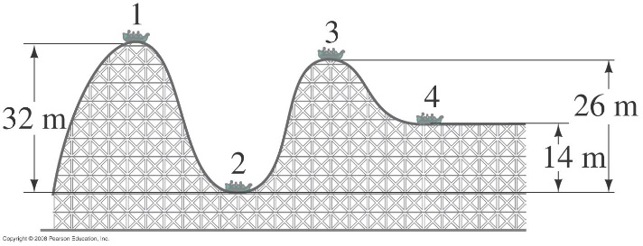

**23.** (II) A block of mass *m* is attached to the end of a spring (spring stiffness constant *k*), Fig. 8–35. The mass is given an initial displacement  from equilibrium, and an initial speed  Ignoring friction and the mass of the spring, use energy methods to find (*a*) its maximum speed, and (*b*) its maximum stretch from equilibrium, in terms of the given quantities.

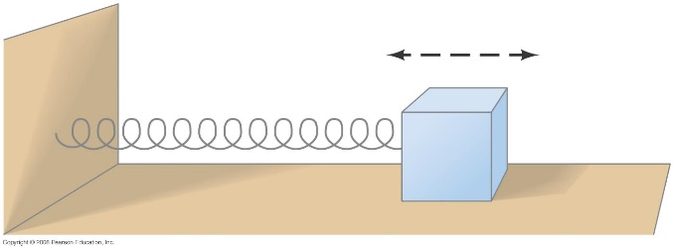

**33.** (II) A 96-kg crate, starting from rest, is pulled across a floor with a constant horizontal force of 350 N. For the first 15 m the floor is frictionless, and for the next 15 m the coefficient of friction is 0.25. What is the final speed of the crate?

**68.** (II) A 1400-kg sports car accelerates from rest to  in 7.4 s. What is the average power delivered by the engine?

**71.** (II) A ski area claims that its lifts can move 47,000 people per hour. If the average lift carries people about 200 m (vertically) higher, estimate the maximum total power needed.