**32.** (II) A window washer pulls herself upward using the bucket–pulley apparatus shown in Fig. 4–36. (*a*) How hard must she pull downward to raise herself slowly at constant speed? (*b*) If she increases this force by 15%, what will her acceleration be? The mass of the person plus the bucket is 72 kg.

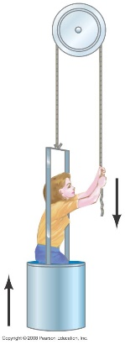

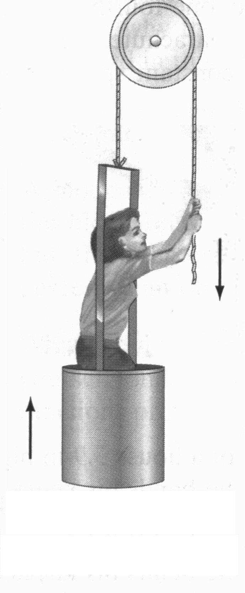32. The window washer pulls down on the rope with her hands with a tension force so the rope pulls up on her hands with a tension force The tension in the rope is also applied at the other end of the rope, where it attaches to the bucket. Thus there is another force  pulling up on the bucket. The bucket-washer combination thus has a net force of  upwards. See the adjacent free-body diagram, showing only forces on the bucket-washer combination, not forces exerted by the combination (the pull down on the rope by the person) or internal forces (normal force of bucket on person).

(*a*) Write Newton’s second law in the vertical direction, with up as positive. The net

force must be zero if the bucket and washer have a constant speed.



*(b*) Now the force is increased by 15%, so  Again write Newton’s

second law, but with a non-zero acceleration.



**35.** (II) Two snowcats in Antarctica are towing a housing unit to a new location, as shown in Fig. 4–38. The sum of the forces  and  exerted on the unit by the horizontal cables is parallel to the line L, and  Deter­­mine  and the magnitude of 

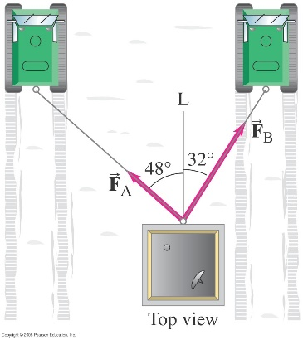

35. Choose the *y* direction to be the “forward” direction for the motion of the snowcats, and the *x* direction to be to the right on the diagram in the textbook. Since the housing unit moves in the forward direction on a straight line, there is no acceleration in the *x* direction, and so the net force in the *x* direction must be 0. Write Newton’s second law for the *x* direction.



Since the *x* components add to 0, the magnitude of the vector sum of the two forces will just be the

sum of their *y* components.



**48.** (II) The block shown in Fig. 4–43 has mass  and lies on a fixed smooth frictionless plane tilted at an angle θ= 22° to the horizontal. (*a*) Determine the acceleration of the block as it slides down the plane. (*b*) If the block starts from rest 12.0 m up the plane from its base, what will be the block’s speed when it reaches the bottom of the incline?

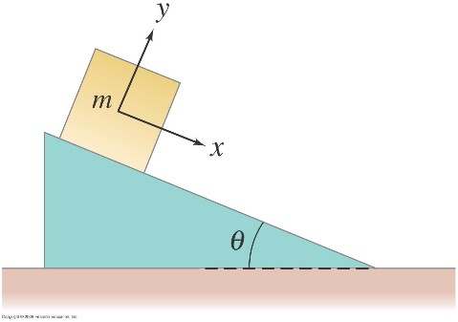

*y*

*x*

**

**

48. (*a*) Consider the free-body diagram for the block on the frictionless

surface. There is no acceleration in the *y* direction. Use Newton’s second law for the *x* direction to find the acceleration.



(*b*) Use Eq. 2-12c with  to find the final speed.



**49.** (II) A block is given an initial speed of 4.5 m/s up the 22° plane shown in Fig. 4–43. (*a*) How far up the plane will it go? (*b*) How much time elapses before it returns to its starting point? Ignore friction.

*y*

*x*

**

**

49. (*a*) Consider the free-body diagram for the block on the frictionless

surface. There is no acceleration in the *y* direction. Write Newton’s second law for the *x* direction.



Use Eq. 2-12c with  and  to find the distance that it slides before stopping.



(*b*) The time for a round trip can be found from Eq. 2-12a. The free-body diagram (and thus the acceleration) is the same whether the block is rising or falling. For the entire trip,  and 



**52.** (II) (*a*) If  and  in Fig. 4–45, determine the acceleration of each block. (*b*) If initially  is at rest 1.250 m from the edge of the table, how long does it take to reach the edge of the table if the system is allowed to move freely? (*c*) If  how large must  be if the acceleration of the system is to be kept at 

52. (*a*) From Problem 51, we have the acceleration of each block. Both blocks have the same

acceleration.



(*b*) Use Eq. 2-12b to find the time.



(*c*) Again use the acceleration from Problem 51.



**54.** (III) Suppose the pulley in Fig. 4–46 is suspended by a cord C. Determine the tension in this cord after the masses are released and before one hits the ground. Ignore the mass of the pulley and cords.

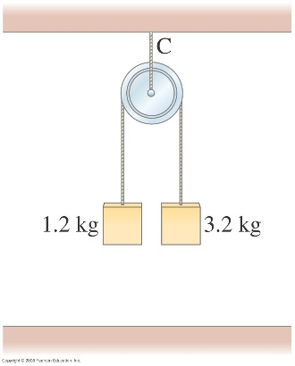

*m*2

1.2 kg

*m*1

3.2 kg

54. We draw a free-body diagram for each mass. We choose UP to be the positive direction. The tension force in the cord is found from analyzing the two hanging masses. Notice that the same tension force is applied to each mass. Write Newton’s second law for each of the masses.



Since the masses are joined together by the cord, their accelerations will have the same magnitude but opposite directions. Thus  Substitute this into the force expressions and solve for the tension force.



Apply Newton’s second law to the stationary pulley.

