**Homework 2 PHYS 211 Dr. Amir**

3. A particle at $t_{1}=-2.0 s$ is at $x_{1}=4.3cm$ and at $t_{2}=4. 5s$ is at $x_{2}=8.5cm$ what is its average velocity? Can you calculate its average speed from these data?

8. The position of a small object is given by  where  is in seconds and *x* in meters. (*a*) Plot *x* as a function of  from  to  (*b*) Find the average velocity of the object between 0 and 3.0 s. (*c*) At what time between 0 and 3.0 s is the ­instantaneous velocity zero?

12. Two locomotives approach each other on parallel tracks. Each has a speed of 95 kmh with respect to the ground. If they are initially 8.5 km apart, how long will it be before they reach each other? (See Fig. 2–38).

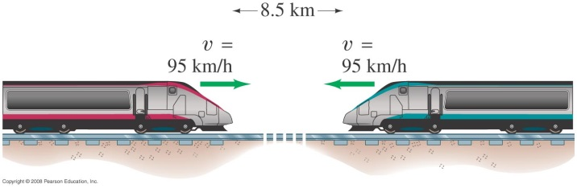

22. A sprinter accelerates from rest to 9.00 ms in 1.28 s. What is her acceleration in (*a*) (*b*) 

27. A particle moves along the *x* axis. Its position as a function of time is given by  where  is in seconds and *x* is in meters. What is the acceleration as a function of time?

29. The position of an object is given by  where *x* is in meters and  is in seconds. (*a*) What are the units of *A* and *B*? (*b*) What is the acceleration as a function of time? (*c*) What are the velocity and acceleration at  (*d*) What is the velocity as a function of time if $=At+Bt^{-3}$?

1. A runner hopes to complete the 10,000-m run in less than 30.0 min. After running at constant speed for exactly 27.0 min, there are still 1100 m to go. The runner must then accelerate at  for how many seconds in order to achieve the desired time?